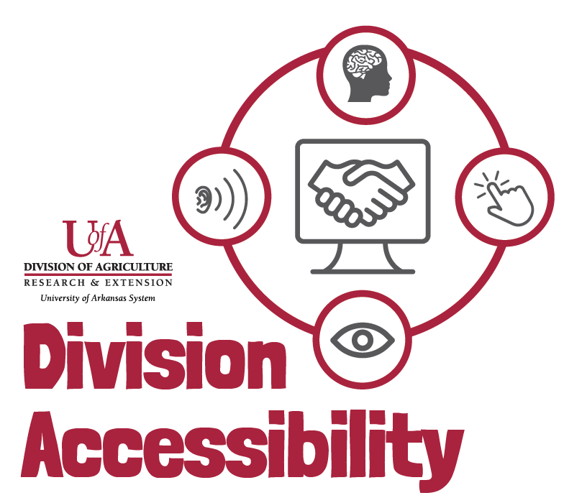Accessible Audio and Video Transcripts
By following this checklist, you can make sure that your transcripts follow Extension accessibility requirements.

I have checked that the transcript is accurate and honest.

I have checked the spelling of uncommon, long, or complicated language.
- Scientific names
- Places and locations
- Chemical names
- Acronyms

I have added non-speech sounds to my transcript if they are important to the context of the audio.

I have identified my speakers throughout my transcript, if applicable.

I have structured my transcript to be read with paragraphs and punctuation.

I have uploaded my transcript as an accessible Microsoft Word document.

Need More Help?
If you are still having trouble making your transcripts accessible, or you have questions, please contact us by email.
Madison Ellis – Accessibility Specialist – mjellis@uada.edu
Amy Cole – Digital Media Program Manager – accole@uada.edu

