Writing and Recording County Checks
Version Date | February 2026
Policies & Resources | No Official Policies & Resources
Forms | Volunteer Purchase Request; Reimbursement Request; Official Function Form
Contacts | Cash@uada.edu
Related Guides | No Official Related Guides

Introduction
Unlike UADA departments and other units, county offices have the ability to write checks for some purchases, although this should not be the primary payment method. In most cases, purchase requisitions or P-Cards should be used to make and/or pay for purchases. Small purchases such as for meeting supplies, some reimbursements to volunteers, and for purchases of immediately needed items may be made with a county check.
When county checks are used for approved payments or reimbursements of volunteers, the check information must be recorded in Workday using the Ad Hoc Payment process. This guide explains the criteria and mechanics of writing county checks as well as how to complete the Ad Hoc Payment process in Workday.

Allowable Expenditures for County Checks
Although county checks should be used sparingly, examples of allowable expenditures paid with county checks include:
- Office & Meeting supplies
- Demonstration supplies
- Group meals for official functions (No alcohol) when accompanied by an Official Function Form and list of attendees
- Equipment (not computers) < $500
- Printing Services < $500

County checks should never be used to pay or reimburse an employee or other county office, should not be used to issue refunds, and should not be used to pay grant expenses. Checks should not be written for M&O expenses which should be purchased via the requisition process. (Most M&O items are on state contract.)

Volunteer Purchases
When volunteer groups such as Master Gardeners and 4-H Clubs need meeting or fundraising supplies, etc., they should submit a Volunteer Purchase Request to the county office. If approved, the county office will determine the best purchase option such as requisition, P-Card, Amazon, or county check. Volunteers should not automatically make purchases themselves and expect reimbursement. If the use of personal funds and subsequent reimbursement is appropriate, a Reimbursement Request should be submitted to the county office within 30 days of the purchase. The request should be accompanied by a valid, legible receipt.

Writing County Checks
Normally checks are written by the Administrative Assistant and signed by the Staff Chair or District Director in the absence of the Staff Chair. The person writing the check should make sure all supporting documents are legible and accounted for before the check is written. Those signing the check should verify the supporting documentation and justification for the check.
To be considered valid, receipts should contain the following legible information:
- Date of transaction
- Name of vendor and when applicable, customer name
- Quantity and description of items purchased
- Any additional details of transactions (shipping taxes etc.)
- Method and date of payment
Examples of other supporting documents include a signed Official Function Form, list of attendees (if food was purchased), and a Reimbursement Request from volunteer, if appropriate. A copy of the check will also be needed to submit the transaction in Workday.
Depending on procedures adopted by the county office, checks may only be written periodically. For example, some offices only write and/or sign checks on Fridays. Personnel are not required to write checks daily or upon demand by employees or volunteers. It is important to set and communicate expectations to avoid misunderstandings.
Checks can be mailed or picked up at the Extension office.

Creating an Ad Hoc Payment in Workday
When county checks are issued, the information must be entered in Workday through the Ad Hoc Payment process. It is best to create the Ad Hoc Payments as soon as possible after checks are issued, or at least weekly.
Log in to Workday and type Create Ad Hoc Payment in the search bar and select Create Ad Hoc Payment from the Search Results.
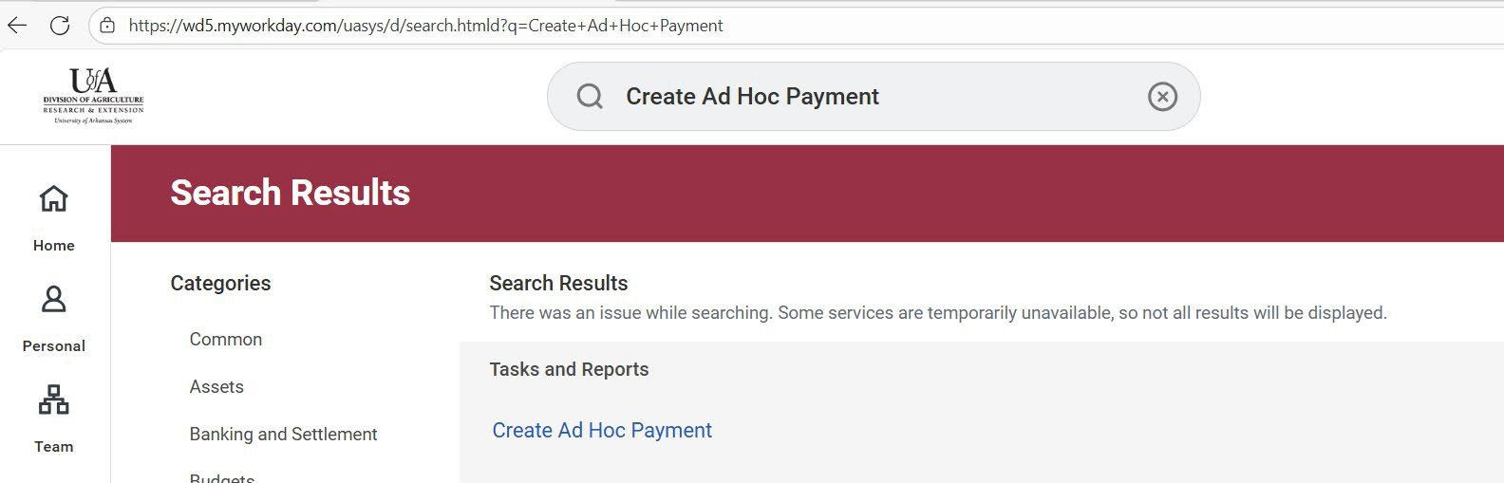

- In the Bank Account field, enter UADA. Then select UADA/CES Arvest County Account from the Search results.
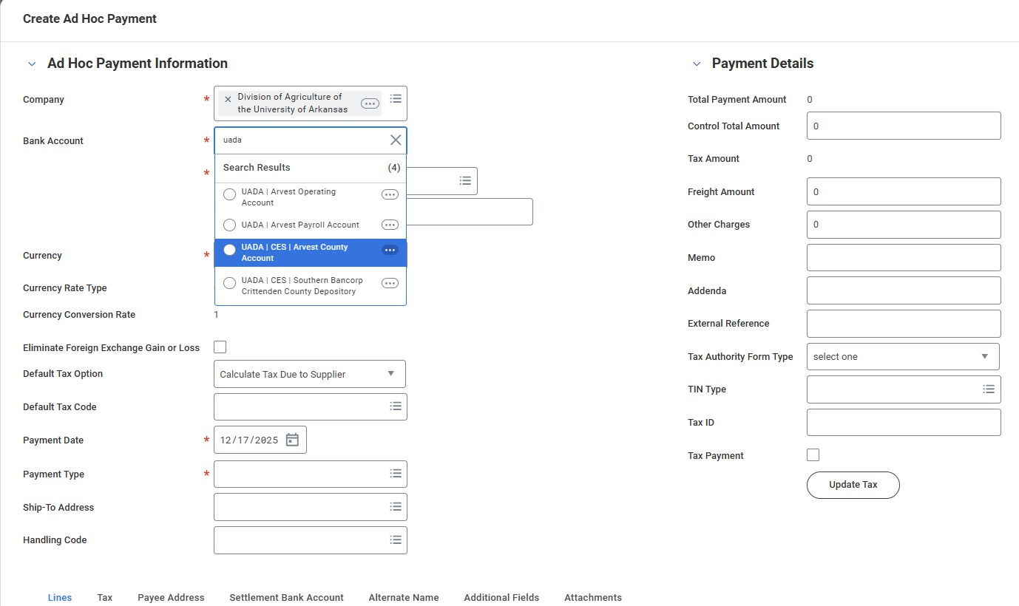

Create Ad Hoc Payment – Left Side of Screen
1  2  3  4  5  6  7  8  9  10  11  12  13  14 | 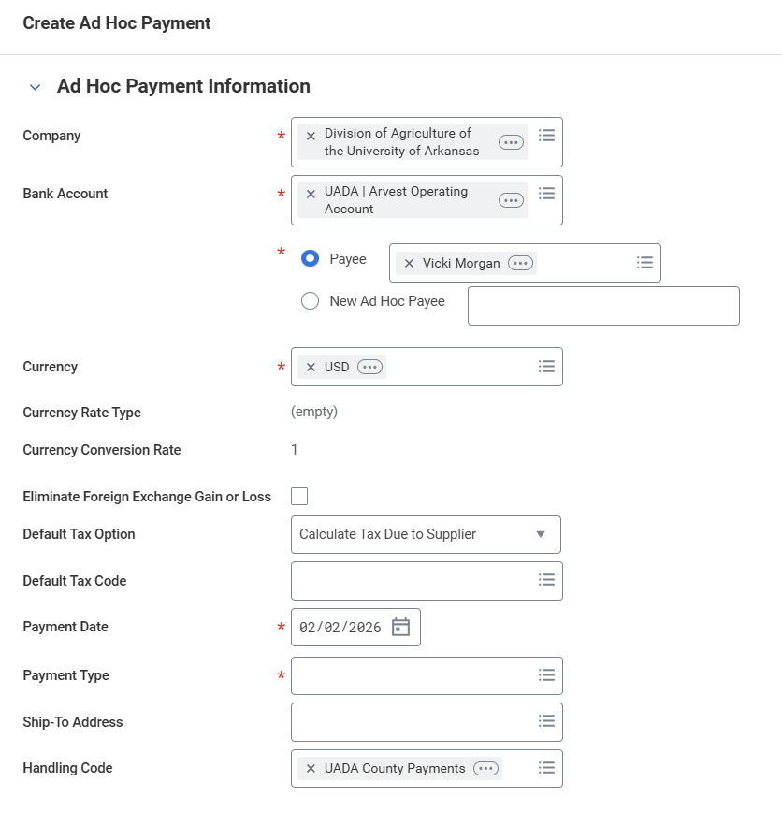
- (Company) This will default to Division of Agriculture of the University of Arkansas.
- (Bank Account) Enter UADA and search; then select Arvest County Account (NOT Arvest Operating Account).
- (Payee) Search previously used name of payee here. If no results, you will need to enter a new payee. (See next step.)
- (New Ad Hoc Payee) Enter the name exactly as it appears on the check.
- (Currency) This should default to USD. If not, type in USD.
- (Currency Rate Type) Leave alone.
- (Currency Conversion Rate) Leave alone.
- (Eliminate Foreign Exchange Gain or Loss) Leave blank.
- (Default Tax Option) Leave alone.
- (Default Tax Code) Leave blank.
- (Payment Date) Enter the date shown on the check.
- (Payment Type) Enter the word Manual or search and select Manual.
- (Ship-To Address) Leave blank.
- (Handling Code) Type in County. It should pull up UADA County Payments.

Do not hit Submit yet!!
Create Ad Hoc Payment – Right Side of Screen
15  16  17  18  19  20  21  22  23  24 |  | 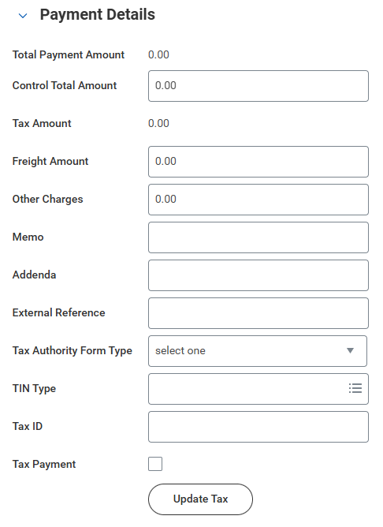
- (Control Total Amount) Enter amount as shown on check.
- (Tax Amount) Leave at 0.00
- (Freight Amount) Leave at 0.00
- (Memo) Leave blank.
- (Addenda) Leave blank.
- (External Reference) Enter 8-digit check number with no spaces.
- (Tax Authority Form Type) Do not select anything.
- (TIN Type) Leave blank.
- (Tax ID) Leave blank.
- (Tax Payment) Leave blank.

Do not hit Submit yet!!

At the bottom of the Create Ad Hoc Payment screen is a scrolling table with several sections including the following:
You will need to complete the fields in the Lines section as described below. Use the bottom scroll arrow to move to ﬁll more boxes to the right.

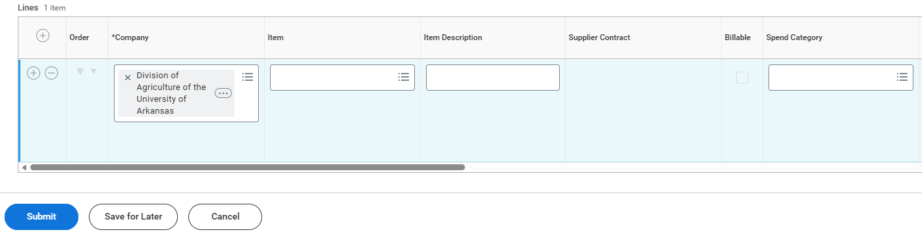
  - (Company) It should default based on previous entries that were entered on the information page.
  - Item - Leave blank.
  - (Item Description) Give a description of what the payment is for. In this example, it was a reimbursement for 4H meeting supplies.
  - (Spend Category) Scroll down to select spend category. Two of the most common options used are:
    - SC0013 Food & Beverage. (Must have a completed Official Function Form and attendance sheet)
    - SC0007 Other Supplies

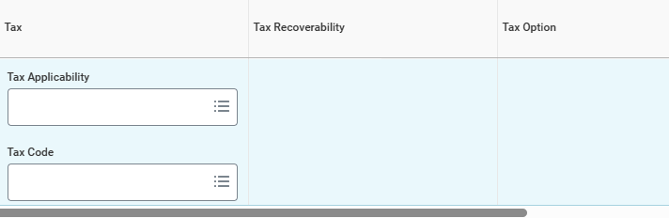

- (All Tax Fields) Leave blank.
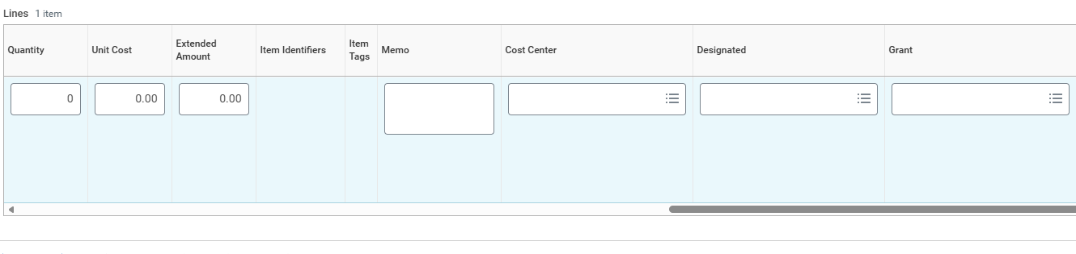

- (Quantity) Enter 1.
- (Unit Cost) Enter the total amount of the check.
If more than one spend category is needed, another line may be added by
clicking the +.
- (Extended Amount) This should auto populate based on Quantity and Unit Cost.
- (Memo) Copy the information used in Item Description here.
- (Cost Center) Enter your county’s cost center code.
- (Designated) Also known as a driver work tag. Enter the number that corresponds with where the money is to be deducted, such as Master Gardeners, 4-H clubs, etc.
- Grant should be blank. This box can be hidden if needed.

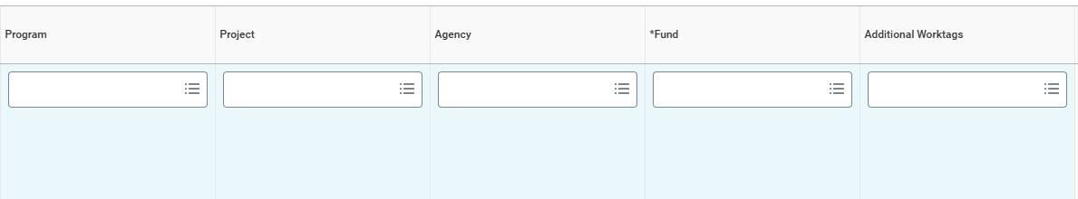

- Program, project, agency, all should be blank. These boxes can be hidden if needed.
- Additional work tags and fund will be automatically generated based on your previous selections.

Attach Documents
When all appropriate fields have been completed in the Lines section, you should attach supporting documents.
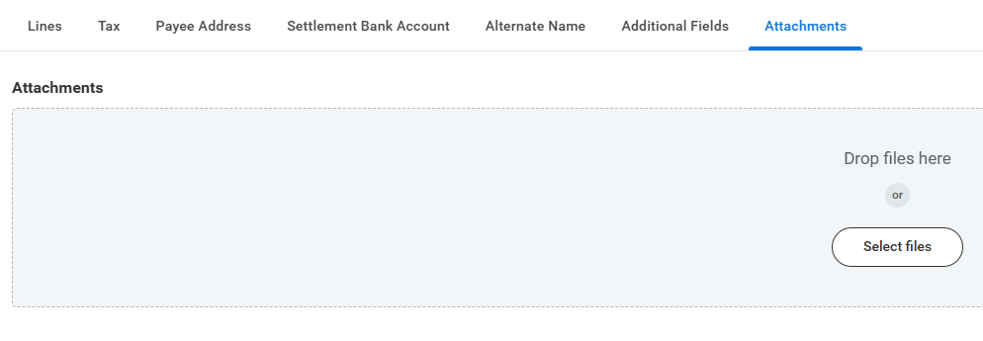
Combine supporting documentation in pdf format making sure that all the pages are easy to read.

Double Check
At this point, you have entered a large amount of information. Double check all fields and attachments. Errors can cause transactions to be returned for correction, increasing processing time and delaying completion and posting in Workday. When you are confident all information is correct, click Submit.

Next Steps
After the Ad Hoc Payment is submitted in Workday it is routed to the Staff Chair for approval. For some spend categories, the transaction may also require review and approval by the Associate Vice President for Finance and Administration. The final approval required is that of the Fiscal Support Analyst for County Accounts. Approvers generally verify allowability of the transaction, availability of funds, and inclusion of all appropriate documentation. When all approvals are received, the transaction is processed and posted in Workday.

