Completing a Workday Expense Report
Version Date | October 2026
Policies & Resources | UADA Travel Policy
Forms | TRAV-207
Contacts | travel@uada.edu; accountspayable@uada.edu
Related Guides | Completing a TRAV-207; In-State and Out-of-State Travel

Introduction
Expense reports are completed in Workday for costs incurred by employees. Whenever possible, it is preferable to use T-Cards, P-Cards, or requisitions for group travel to pay travel and business related expenses. In cases where personal funds of employees are required, reimbursement may be requested by completing a Workday Expense Report. This guide addresses those instances. This guide does not address reimbursement of volunteers or the payment of vendors or service providers.

Expense Reports should be completed as soon as possible but no later than 20 days after travel is complete or other expenses are paid. Expense Reports are required for travel, even if most or all costs are originally paid by UADA without the use of the traveler’s personal funds.

Completing a Workday Expense Report
In the Workday search bar, type Create Expense Report and select Create Expense Report for Worker from the search results. The following screen should appear:

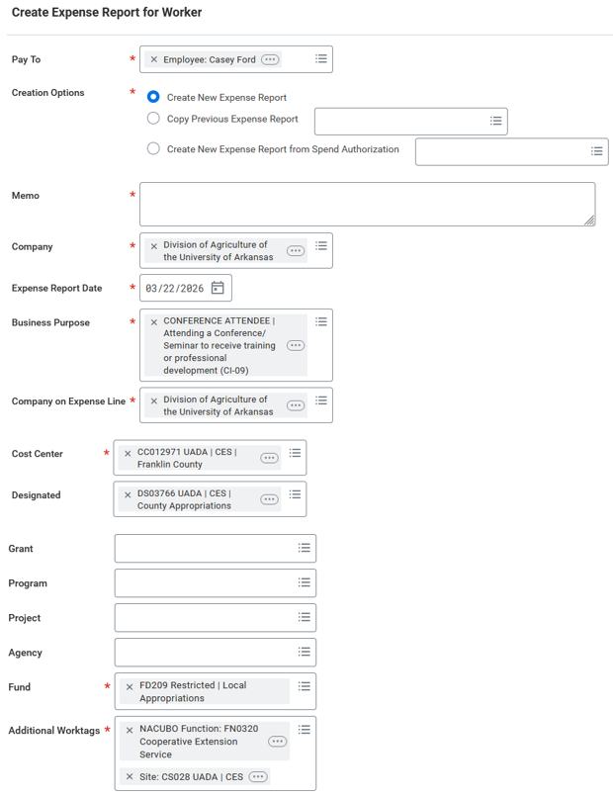

Enter information for the Complete Expense Report for Worker fields as follows:

Create Expense Report for Worker Screen
Field Name | Response
Pay To | Enter the traveler’s name and then select them from the options shown. Then select Create New Expense Report.
Creation Options | Select Create New Expense Report.
Memo | Enter the name of the activity driving the report such as Out-of-State Travel and then enter the month and year of the travel.
Company | Will auto populate to UADA.
Expense Report Date | Will default to current date and must be changed. Enter the last day of travel for out-of-state travel or the last day of the month for in-state travel.
Business Purpose | Choose from dropdown menu: Conference Attendee, External Meeting or Event, etc.
Company on Expense Line | Will auto populate to UADA.
Cost Center | Will auto populate based on traveler’s name/headquarters. Change if necessary.
Designated | Enter one designated worktag. If more than one is necessary, they will be entered on separate expense lines.
Grant, Program, Project, Agency | Leave Blank if Designated Worktag is listed above. Otherwise, list worktag to be charged here.
Fund, Additional Worktags | Will auto populate.

If related charges were made on a T-Card and reassigned to the traveler, they would be listed at the bottom of the screen under Credit Card Transactions. If a T-Card transaction is listed, there will be an “Include” box to check to include the transaction in the Expense Report. Ignore Quick Expenses. (See image below.)

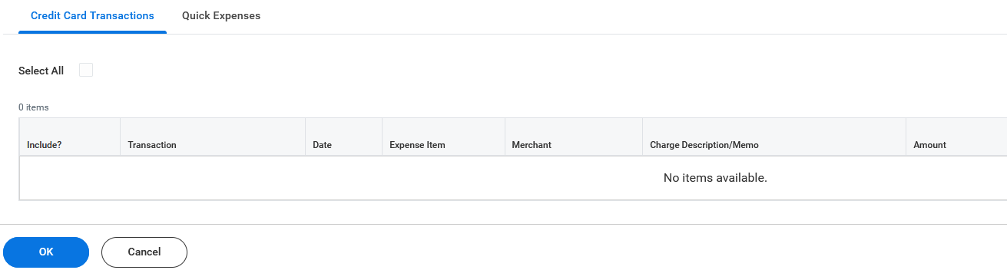
Select OK in the blue button in the bottom left portion of the screen. This will bring up an “Expense Lines” tab.
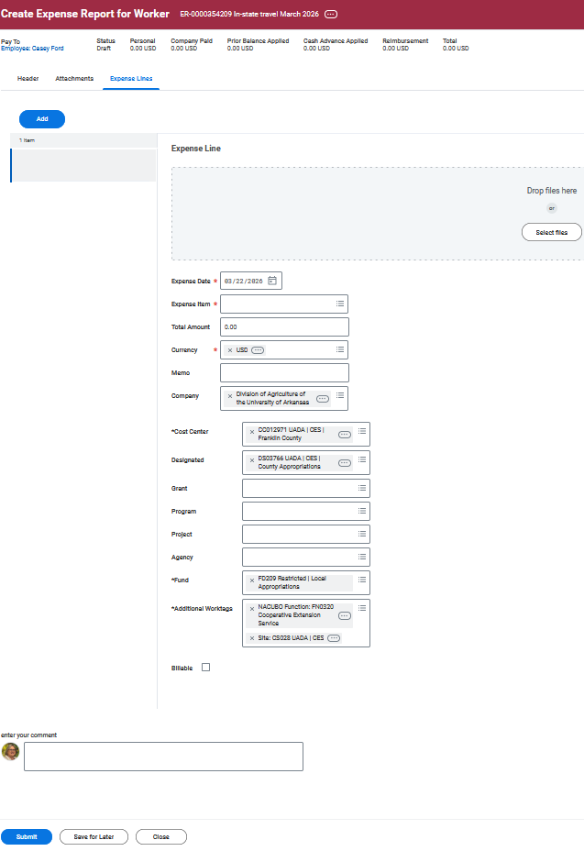

Expense Lines Tab:
Click on the Blue Add button. Then complete the online fields as follows:
Expense Line Screen
Field Name | Response
Drop Files Here | Scan all supporting documents into one file and attach the file to each expense line. Examples of supporting documents include Trav-207, Airline Ticket, Agenda, Travel Authorization Form, Travel Method Comparison Worksheet, Hotel Receipt, Taxi/Uber Receipt, etc. (No need to check the Receipt Included box.)
Receipt Included | Leave blank. If attachments are submitted, the box may be checked automatically.
Expense Date | This will auto populate to the last date of the trip for out-of-state travel or the last day of the month for in-state travel. Be sure to verify the date.
Expense Item | To identify the proper expense item, you may start typing and select the item when it appears, or select a category (Item Group, Spend Category, or Alphabetical Order) from the dropdown list. Then select the appropriate expense such as Mileage. Depending on what is selected, additional fields will be displayed and require completion.
Total Amount | Enter amount for this expense.
Currency | Will auto populate with USD.
Memo | Enter see Attached TRAV-207 and note any other information that may be unusual or of particular interest to the reviewer. Ex: If lodging is over per diem, provide explanation.  Ex: If more than one cost center is needed.
Company | Will auto populate based on data from previous screen.
Cost Center | Will auto populate based on data from previous screen.
Designated | Will auto populate based on data from previous screen.
Grant, Program, Project, Agency | Will auto populate based on data from previous screen.
Fund, Additional Worktags | Will auto populate based on data from previous screen.
Billable | Leave unchecked.
Enter Your Comment | Leave blank.

Note: If you have multiple Driving Tags, you will need to enter an Expense Line for each Driving Tag listed on the Summary page of the TRAV-207 form.

Expense Items
An expense item will be required to continue with the Workday Expense Report. This section provides guidance for completing fields required for Mileage, Meals, and Hotel Accommodations. Other expense categories may be required but are too numerous to describe. The three examples provided are some of the most frequently incurred expenses.

Depending on the Expense Item selected from the dropdown, different information will be required. To select an Expense Item, you may search by Expense Item Group, by Spend Category, by Alphabetical Order, or type the name of the expense, such as mileage, hit enter, and select the correct expense from the search results.

Expense Item – Mileage
When Mileage (Domestic) (Private Vehicle/Aircraft) is selected, Rates Used will be added to the left side of the screen and auto populate with the State of Arkansas approved rate per mile. Total Amount and Currency will also be added. No entry is required in these fields. Other fields in the left column will either auto populate or can be left blank. The key area of focus is the right side of the screen beneath Instructions as shown below.
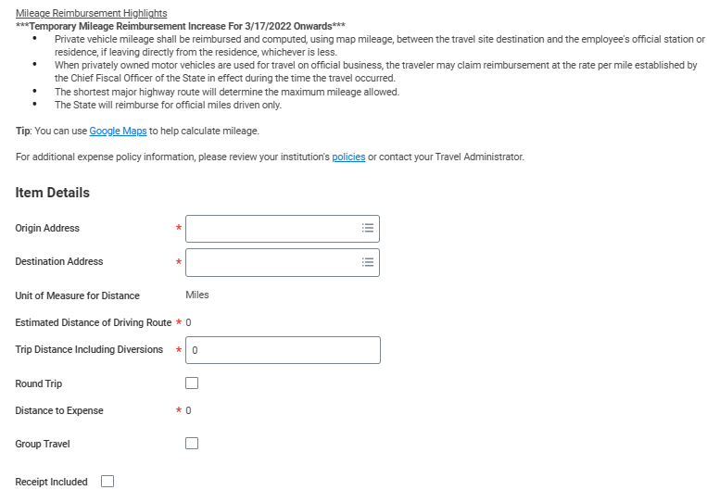

Expense Item – Mileage – Right Side
Field Name | Response
Origin Address | Enter the complete address of the traveler’s headquarters/ county office. As you type, the address should appear and can be selected.
Destination Address | Type in your headquarter Town/City and State (only). Start typing and then choose. The actual mileage will be recorded via the TRAV-207 entry.
Trip Distance Including Diversions | Type in total miles from your TRAV-207 for this Cost Center and Designated Fund.
Round Trip | Do not check. You’ve already entered all miles traveled per TRAV-207.
Group Travel | Check only when other people (not employees) are traveling with you. (See Section 17 of the UADA Travel Policy.) A list of the other people and their roles is required. If the explanation is simple, it can be entered in the Justification field of the Spend Authorization. Lengthy or more complicated explanations are better described in an attachment.
Receipt Included | Leave blank. If attachments are submitted, the box may be checked automatically.

To Add additional Expenses, click the blue Add button in the top left corner of the screen.

If no other expenses are to be claimed and all necessary files have been attached, click the blue Submit button at the bottom left corner of the screen. You should see an on-screen message that the expense report has been submitted and identifying the next person to review the report.

Expense Item - Meals Per Diem – Domestic
Search for and select Meals Per Diem – Domestic and complete the required fields as follows. For the left side of the screen, everything will auto populate or can be left blank except for Memo. In the memo field enter Meals not provided.

Right side of Screen 1:

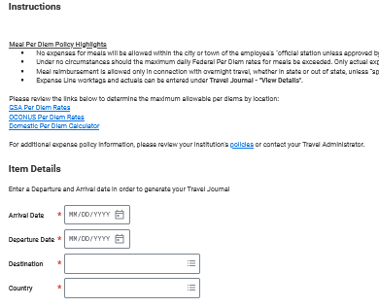

Note: As soon as dates are entered, these additional fields appear:
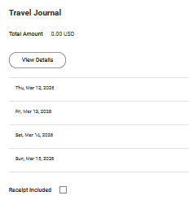
Meals Per Diem – Screen 1, Right Side
Field Name | Response
Arrival Date | Enter first day of travel.
Departure Date | Enter last day of travel.
Destination | Enter City and State / Choose from list.
Country | Will auto populate.
Travel Journal | Select View Details and Screen 2 will be displayed.

When View Details is selected under Travel Journal, the following screen is displayed (Screen 2).
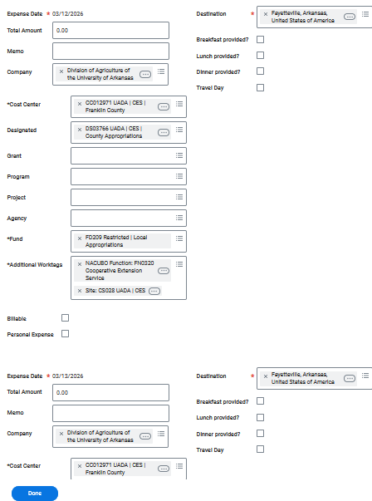

Meals Per Diem – Screen 2
Field Name | Response
Expense Date & Destination | Auto populates each day of travel status.
Total Amount | Type in total of actual meal expenses (Breakfast/Lunch/Dinner) for that day.  NOTE: You must enter an amount in this field or an error will generate. If no meals are to be reimbursed on a particular day, enter $0.01 and take a penny off one of the other days. This way the total reimbursement will be the same and no errors will occur.
Memo | Type in any notes such as “Travel day meals were not provided.”
Breakfast/Lunch/Dinner Provided | Click to check any meals provided at the Conference/Event that day.
Travel Day | Click to check if it is a Travel Day.
Company, Cost Center, Designated | Will auto populate. Change if necessary.
Everything Else | Leave blank.
Scroll down and provide this information for each day of the trip.

Click the blue Done button when all meal information has been entered.
The screen will return to the Expense Lines screen as shown on page 4. If no other expenses need to be entered and all necessary files have been attached, click the blue Submit button at the bottom left corner of the screen. You should see an on-screen message that the expense report has been submitted and identifying the next person to review the report.
If you have another expense item to enter, click the blue Add button on the top left corner of the screen.

Expense Item - Hotel Accommodations – Domestic
Search and select Hotel Accommodations – Domestic and complete the screens as discussed below. Note: Workday will automatically bring you to the following screen as the first travel expense item if there is a T-card charge for hotel accommodations.

Left side of screen:

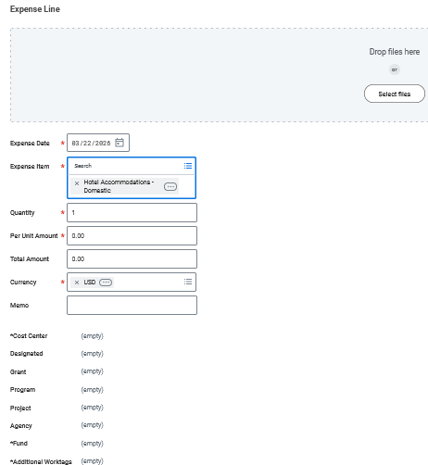

Hotel Accommodations – Screen 1, Left Side
Field Name | Response
Drop Files Here | Attach hotel receipt (or file with all attachments). Make sure the hotel receipt shows a zero balance.
Expense Date | Will auto populate to last day of travel.
Quantity | Enter number of business-related nights.
Per Unit Amount | Enter cost of each night.
Total Amount | Enter total amount for all nights, including tax. Tax and room charge will be separated under Daily Expenses.
Memo  Memo (Continued) | Add any explanatory notes here.  Note: If room is charged to someone else’s T-Card, then you need enter that person’s Expense Report # here. If the hotel cost exceeds per diem, note the reason here. An example might be “Hotel did not offer the state rate, Rate was for conference rate which exceeds the per diem, hotel was selected for safety reasons, etc.

Right side of screen:
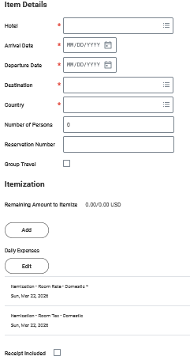
Workday will track and total amounts entered.
Hotel Accommodations – Screen 1, Right Side
Field Name | Response
Hotel | Enter / Select name of hotel.
Arrival Date | Enter check-in date.
Departure Date | Enter check-out date.
Destination | Type City and State and choose from list.
Country | Will auto populate.
Number of Persons | Leave blank.
Reservation Number | Optional
Group Travel | Check if non-employees stay overnight. Must provide information about who stayed and in which rooms either in the Spend Authorization or in an attachment.
Itemization | Select Edit under Daily Expenses to display the screen below.

After selecting Edit under Daily Expenses, the following screen will be displayed (Screen 2).
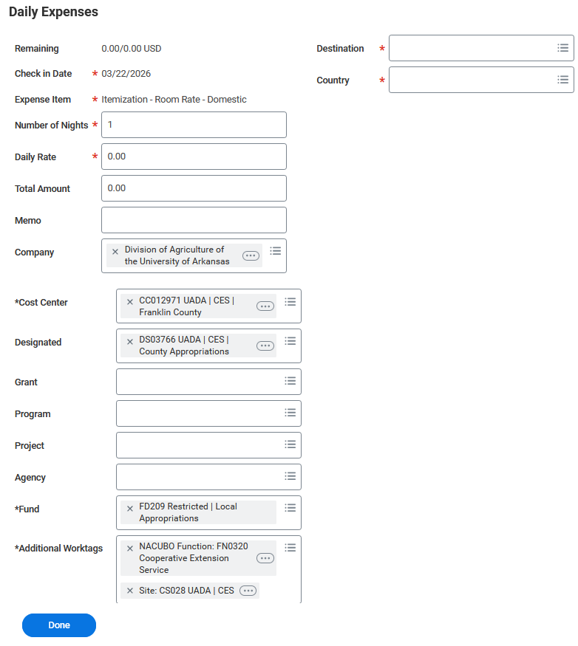
Amount left to itemize.

Hotel Accommodations – Screen 2
Field | Response
Destination | Auto populates or enter city and select from search results.
Country | Auto populates.
Expense Item | Auto populates with Itemization- Room Rate – Domestic  NOTE: One Expense will be Room Rate and the other Room Tax. Sometimes the first one listed will be Room Rate, but sometimes it will be Room Tax. Follow on-screen prompts.
Number of Nights | Enter the number of nights at the hotel.
Daily Rate | Enter daily room rate without taxes.
Total Amount | Will auto populate.
Memo | Enter notes helpful to approvers here.
Everything Else | Will auto populate or should be left blank.

When information for all expense items and days of travel has been entered, select the blue “Done” button to submit the Expense Report.

Next Steps
When the Workday Expense Report is submitted, it will be routed to the traveler for review and then the Staff Chair for approval. If the Staff Chair is the traveler, it will be routed to the Staff Chair for review and then the District Director for approval. Following approval by the Staff Chair or District Director, the report is sent to the Business Office for final review and approval. The Business Office makes every effort to fully process and generate payment for expense reports with 7 business days of receipt by the first Business Office reviewer in Workday.

