Using Travel Cards
Version Date | October 2026
Policies & Resources | UADA_380_1.pdf  UADA Travel Resources  Card Use Matrix
Forms | Travel Authorization Form
Contacts | Travel@uada.edu
Related Guides | Travel Card Expense Reassignment; In-State and Out-of-State Travel

Introduction
There is often confusion about how to pay for travel expenses. What exactly can a Travel Card (T-Card) be used for? When can a P-Card be used? What about personal reimbursement? This guide explains when the use of a T-Card is appropriate and how to use a T-Card correctly. The guide does not cover all travel policies, but related policies are linked above.
Individuals are not assigned Travel Cards. Instead, T-Cards are assigned to departments, counties, etc. and used for the benefit of all employees in that unit. Furthermore, T-Cards can only be used for expenses such as registration, airfare, lodging and travel-related rental cars that are paid in advance. While T-Cards may be used for in-state travel, most usage involves out-of-state travel. Under no circumstances may the card be taken outside the office or with the employee as they travel.
A summary of expenses that can be paid with a T-Card can be found in the UADA Credit Card Matrix. The remainder of this guide describes how to use a T-Card to pay authorized travel expenses.

Prior Approval to Travel
- Out of State travel requires an approved Workday Spend Authorization OR Travel Authorization Form prior to travel expenses being incurred. For county offices, the Travel Authorization Form should be used for domestic travel, and the Workday Spend Authorization is used for international travel. Spend Authorizations are required for all travel types if a cash advance is requested by the traveler.

- When the Travel Authorization Form is used, it should be signed by the Staff Chair as Supervisor unless the Staff Chair is the traveler. In that case, the District Director will sign as Supervisor and no signature is required for Department Head. If the Staff Chair signs as Supervisor, the District Director will sign as Department Head.
- The approved form is maintained in the county office until travel is complete and the related Expense Report is completed. The Travel Authorization Form will be submitted as an attachment to the Expense Report.

Conference/Registration Fees
- Although T-Cards are preferred, P-Cards can be used to pay Conference/Registration fees if there is no travel component included in the event, and the event is not a UADA-sponsored activity. If other travel expenses such as meals, hotel, etc. are expected, conference fees must be paid with a T-Card.

- If the event is a UADA organized event, registration should be paid through an Internal Service Delivery (ISD) charge in Workday. T-Cards cannot be used for UADA events.

Hotel Registration
- T-Cards are the only approved UADA credit cards for the payment of lodging expenses. To make hotel reservations, call the hotel or book online from the hotel website, making sure not to book through a booking service that charges extra fees.

- After using the T-Card to reserve rooms (over the phone or via the hotel website), call the hotel and request a Credit Card Authorization Form. Explain that the room will be paid for with a company card, and the individual will not have the card with them at the time of the trip. Complete the online form including only room and tax charges (incidentals may not be charged on the T-Card), submit it to the hotel, and save it for your files. It is recommended that the traveler take copies of confirmations with them when they travel in case the hotel has trouble finding the reservation.
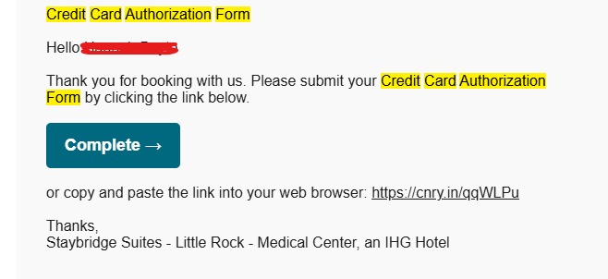
- When travel is complete, the traveler should bring you a zero-balance receipt and/or the hotel will email the zero-balance receipt to you. If there are any issues, contact the hotel.

- Do not use third party travel services. The service fees are not allowable.

Travel-Related Rental Car
- The State of Arkansas has contracts with Enterprise and Hertz. Contact information can be found under the Vehicle Rental link at UADA Travel Resources. UADA county offices usually use Enterprise. The following instructions assume an Enterprise rental car.

- If you frequently use travel-related rental cars, you may benefit by acquiring an Enterprise Rental Car Billing Account Number. If this is the case, contact Travel@uada.ed for assistance. Otherwise, a billing number is not necessary. You will be able to reserve a vehicle using the UADA Enterprise Contract #XZ51R09 and your T-Card.

- To reserve a vehicle, visit: Reserve | Enterprise Rent-A-Car and follow the online prompts. If you have any questions, contact Travel@UADA.edu.

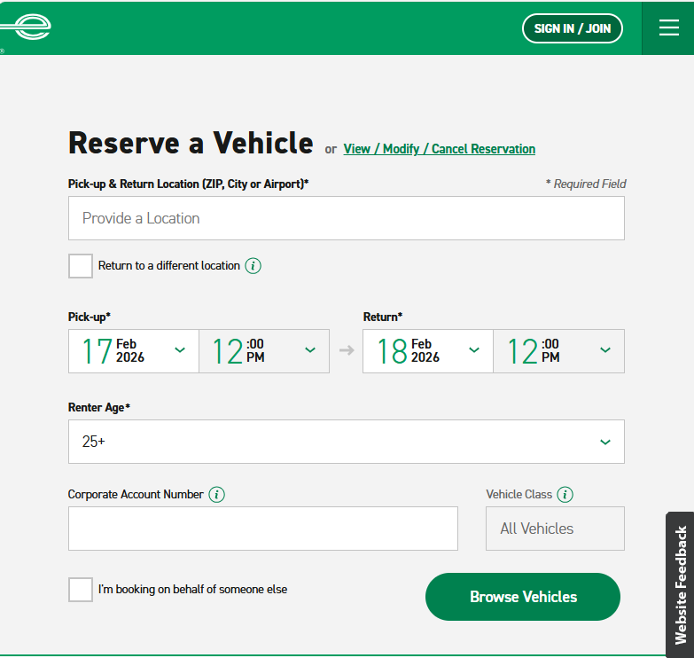

Airline Reservations
- As more fully described in UADA Policy 380.1, travel by commercial air shall utilize coach class fare and the least expensive option for a reasonable flight. (More expensive options must be justified and may not be approved.) Tickets should be purchased at least 14 days in advance when possible. When submitting the related expense report, flight itinerary dates must match the dates approved in the Spend Authorization/Travel Authorization Form or justification must be provided within the Workday Expense Report.

- Airfare may be purchased using a T-card or personal funds. Travelers are eligible for reimbursement for airfare only AFTER the trip has ended and the Workday Expense Report is fully approved and processed by the Business Office.

- When using a T-Card, research and select flights on airline websites just as you would for any flight. When actually booking, enter the T-Card number for payment.

Next Steps
When it’s time to do the Expense Report in Workday, if any charges need to be reassigned to another worker refer to: Travel Card Expense Reassignment.
Generally, T-Card charges should be held (not included in an Expense Report) until the trip is completed. Then all travel expenses for the trip should be included in one expense report. However, all T-Card charges need to be cleared before year-end closing, even if the trip has not occurred. A new Spend Authorization or Travel Authorization Form will be required for travel in the new year.

