Travel Card Expense Reassignment
Version Date | August 2026
Policies | No Official Policies
Forms | No Official Forms
Contacts | Travel@uada.edu
Related Guides | Using Travel Cards; In-State and Out-of-State Travel

Introduction
One Travel Card (T-Card) is issued to each county, and always in the name of the Staff Chair. Any agent in that county office may use the card to pre-pay travel expenses, with the approval of the Staff Chair. Using a T-Card helps reduce the use of personal funds and resulting need for personal reimbursement.
Regardless of who uses the card, all T-Card transactions will post in Workday under the Staff Chair name. If the expense was incurred for a different agent, the charges will need to be manually re-assigned to the agent traveling. It is advisable to do the re-assignment as soon as it is viewable in Workday so that the transaction is ready when the agent completes the travel and the Expense Report is prepared.

Reassigning Expenses
- Go to the Workday Search field and enter Reassign Expense Credit Card and select Reassign Expense Credit Card Transactions from the search results.

- Complete the fields as applicable using the example below. Because the Travel Card is in the name of the Staff Chair, it is their name that should be entered in the Worker Credit Card and Current Expense Payee fields. (Note: In rare instances, the T-Card may be assigned to the District Director or Associate District Director. If that is the case, their name should be entered.) There is no need to enter any dates. Only transactions eligible for reassignment will be listed in the search results. Select OK.
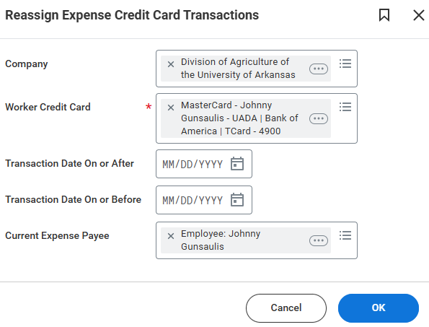
- A screen will appear showing all available T-Card transactions. Go to the New Expense Payee field on the right side of the screen. This is the only modifiable field. Click the “X” next to the name that auto populates in the New Expense Payee field to remove it and type in the name of the traveling agent. The agent’s name, position, county, etc. should appear. Select the appropriate employee from the available options. Click OK at the bottom of the screen.
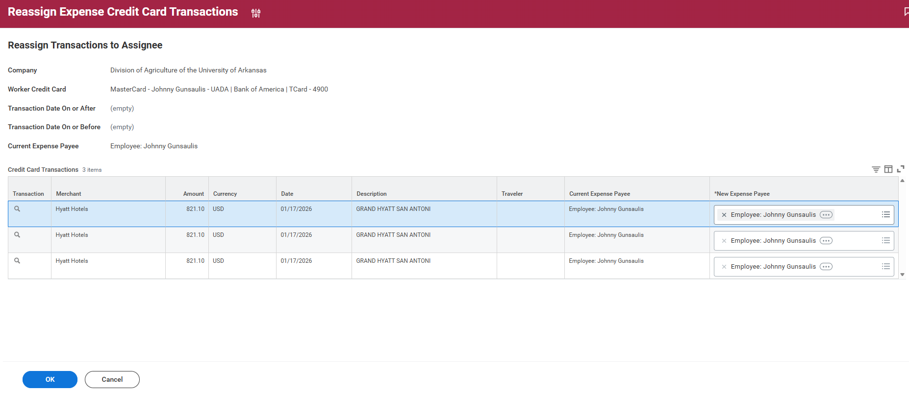

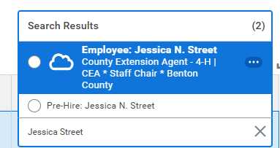
- Next, you will see a confirmation page like the one below. Select Done at the bottom of the screen and you will be returned to the main search page in Workday. You do not need to do anything else with this transaction until the agent returns from the trip unless the trip occurs in the next fiscal year.
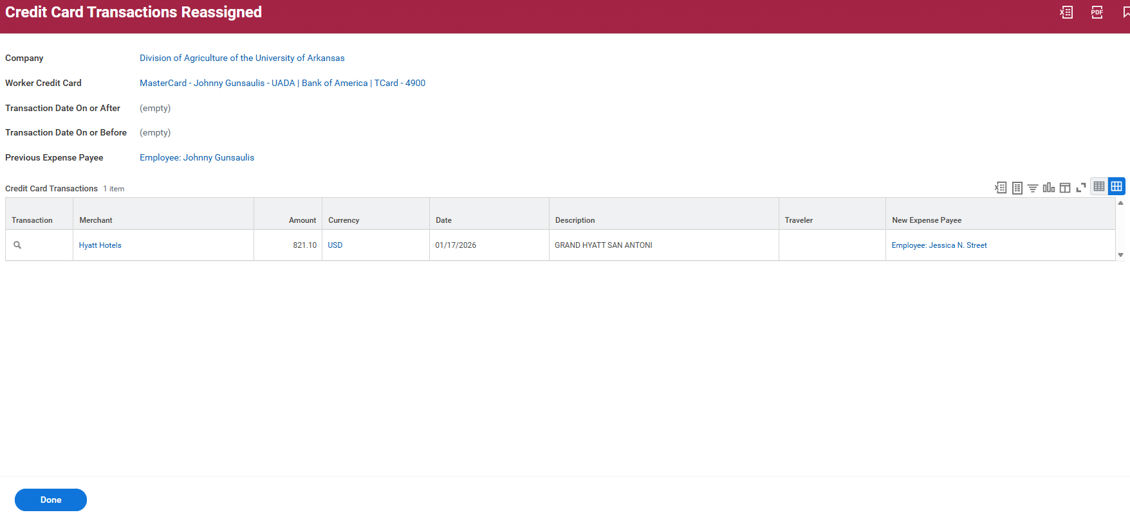

When Travel Is Complete
- When the travel is complete and the agent provides all the necessary documentation, the Expense Report can be completed in Workday.
In the Workday Search field, type Create Expense Report and select Create Expense Report for Worker from the search results.

- Type in traveler’s name and complete other fields, as appropriate. The T-Card expense that was reassigned will be displayed at the bottom of the screen, possibly with other charges. Check the box to “Include” the charge in the expense report and select OK at the bottom of the screen.

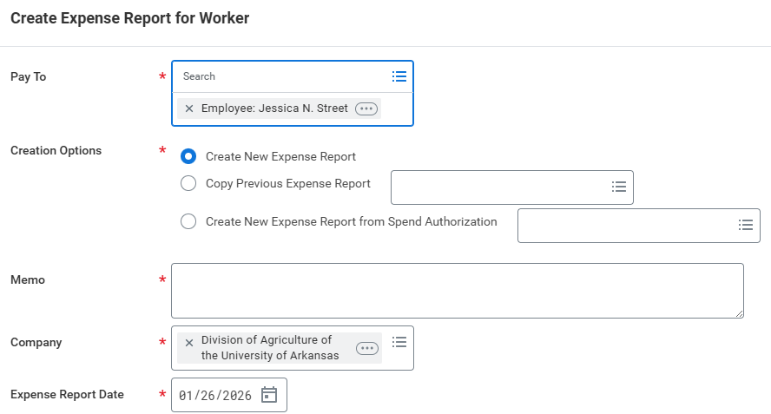

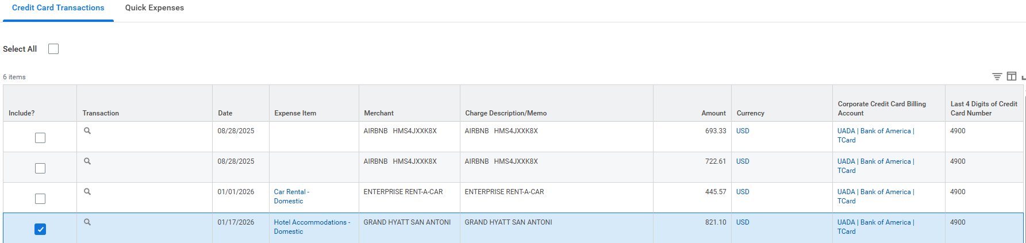

- Complete the remainder of the Expense Report as usual. See Out of State Travel process guide.

Next Steps
Travel Card expense reassignments do not require separate approvals in Workday. When the reassignment process is complete, the charges are cleared. The reassigned charge will be included in the Expense Report when travel is completed and all receipts are collected. The Expense Report will require normal approvals in Workday. See Out of State Travel process guide for details about completing the related Expense Report.

