Receiving and Reporting Gifts
Version Date | October 2026
Policies & Resources | None
Forms | Gift Disclosure Form-UADA (Workday); Non-Cash Gift Form
Contacts | Gift Financial Manager; 1 (479) 387-3970; billingar@uada.edu
Related Guides | Receiving and Depositing Funds

Introduction
All counties within UADA can receive donations, both monetary and nonmonetary, from outside sources. All donations must be receipted, secured, and documented according to sound business practices. Cash receipts should be deposited as soon as possible, preferably daily. Until funds are deposited, they must be secured to prevent theft or loss.
To be considered a gift, there can be no required performance or reporting to the donor by UADA programs or employees. If the donor attached performance or reporting requirements to cash or noncash donations, the exchange is a grant or contract. Contracts and gift agreements may only be signed by persons granted such authority by the UA Board of Trustees. For UADA, currently those individuals are Dr. Deacue Fields III, Matt Brown, Dr. John Anderson, and Dr. J.F. Muellenet.
Because of legislation regarding foreign adversaries and prohibited foreign party countries, it is imperative that all gifts from foreign operatives be approved before being accepted.
This guide describes steps for receiving, safeguarding, and depositing funds in a county office, as well as reporting gifts to the University of Arkansas Division of Agriculture (UADA) development office. For any questions or information related to gifts, contact the Gift Financial Manager at: developmentoffice@uada.edu.

Cash Gifts
Donors may deliver cash gifts to Extension personnel or may choose to donate to a group volunteer for the benefit of the group. All cash gifts received by group volunteers on behalf of a group must be delivered to the county Extension office for deposit. The county Extension office will ensure proper accounting, reporting, receipting, and acknowledgement of all gifts. If the donor designates the gift for a specific program, the county office will ensure the funds are deposited in the appropriate account.
Note: Some businesses require an invoice from which to pay before giving a gift, in this case please reach out to billingar@uada.edu.
For many years, counties were instructed to complete a MISC-400: Gift Disclosure Form for all gifts of $250 or more or those for which the donor requested a tax receipt. However, because of legislation as well as the need for better tracking and reporting of gifts, counties should report ALL gifts (cash and noncash) via a Gift Disclosure Form-UADA (Workday) for cash gifts and a Non-Cash Gift Form for noncash gifts.
Staff Chairs will ensure all gifts are properly acknowledged with a Thank You note. All formal tax receipt letters will be sent from the UADA Development Office. Copies will be provided to the fund manager noted on the Gift Disclosure Form. No county office employee or volunteer should attempt to provide an IRS-acceptable tax receipt!
The Assistant VP for Finance and Administration and/or Gift Financial Manager of the Development Office should be notified when a donation with a written restriction for a specific purpose is received. (This is not the same as designating that the funds be used to support a specific 4-H club or Master Gardener group. The VP for Finance and Administration does not need to be notified about this type of donation.)
The county office should receipt and deposit cash gifts the same as any other cash receipts. (See the Receiving and Depositing Funds guide.) As shown below, a receipt from the official receipt book should be issued. The receipt should reflect the name of the person who brought the money to the office, the donor, and which program/group should benefit from the gift, if appropriate. The white copy goes to the volunteer or agent, the yellow stays with the money and the pink stays in the receipt book.
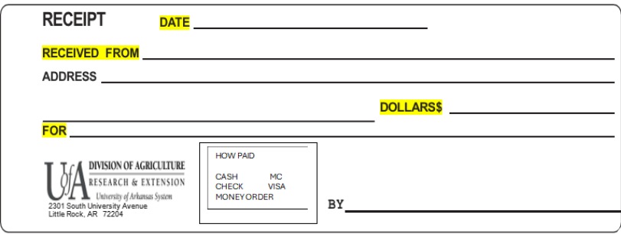

The cash gift would then be combined with any other cash received and deposited in the county depository bank account.

Completing the Gift Disclosure Form

After the gift has been receipted and deposited, the Gift Disclosure Form – UADA (Workday) (below) should be completed.

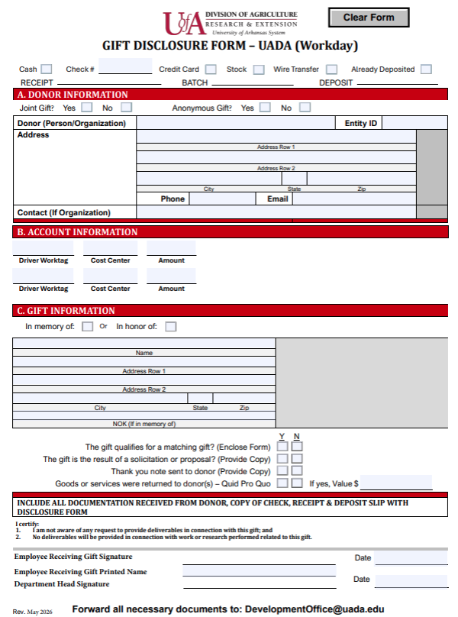
Complete the form as follows:

Header
- Mark the first row: Already Deposited, Check Attached, Non-Cash Gift, Stock or Land. Most will mark Already Deposited or Non-Cash Gift.
- Ignore Receipt, Batch, Deposit. Those are for Development Office use.

Section A.
- Complete the Name of the Donor(s), Contact name if different from Donor, if this is a joint gift, Address, Anonymous Gift, Telephone and email, if they want a Tax receipt.

Section B.
- You will put the Cost Center of the county/Area that is receiving the fund and the Driver Worktag and the Amount. If the Donor wishes for the funds to go to more than one area be sure you ask how much to each area.

Section C.
- Ask if the gift is in memory/honor of someone and fill in their information. If non- cash gift the donor will tell you in writing the fair market value of the goods/services they are giving. Be sure to keep a copy of this letter. Designate if a thank you note has been sent to the donor and submit a copy of it with this form.
- Complete the Yes/No questions, as appropriate.
- The employee who received the gift should sign and date the form along with the Department Head. In a county office, the Staff Chair should sign as Department Head.
Once this form has been completed, it should be emailed to developmentoffice@uada.edu along with a copy of the deposit and any other paperwork that pertains to the gift.
Finally, record the deposit using the information found in the Receiving and Depositing Funds guide. Be sure to include all forms sent to the Development Office.

Noncash Gifts/Sponsorships
It is not uncommon for a county office to receive tangible noncash gifts. Examples include donors buying supplies for 4-H activities, donating items to be auctioned for the benefit of 4-H, providing meals at banquets (sponsorships), donating equipment, etc. When unconventional noncash gifts are offered, approval should be obtained from the Development Office before the gift is accepted. Examples include land, vehicles, or items valued over $5,000. If accepted, a Non-Cash Gift Form should be completed (See below). The form is self-explanatory, and there would be no deposit required. What is important about noncash gifts is that the donor values the donated item. If the donor fails to value the item, the value assigned by the Development Office will be $1. In many cases, the vendor can use a paid receipt to assign value to the gift. However, in some cases, the donor may be required to furnish an appraisal to support the value of the donated item. The Development Office will work with the donor should an appraisal be required.
The completed form should be emailed to DevelopmentOffice@uada.edu.
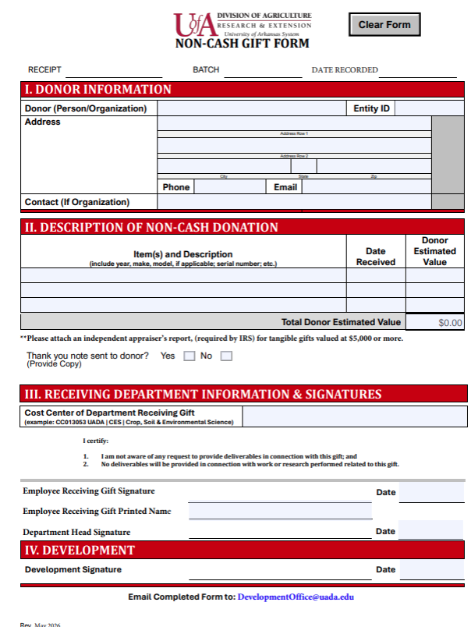

Next Steps
Once notified, the Development Office will provide IRS-acceptable tax receipts to donors. In addition, the Development office maintains an extensive database regarding gifts that now identifies the county, department, and/or program that received the gifts. This way, all units will receive appropriate recognition for their donor support.

