Receiving and Depositing Funds
Version Date | August 2026
Policies & Resources | Financial Guidelines for Extension Clubs & Groups
Forms | Record of Deposit
Contacts | Cash@uada.edu; Fiscal Support Analyst for County Accounts
Related Guides | No Official Related Guides

Introduction
All counties within UADA receive funds from outside sources. These funds might be fees for activities such as Pesticide Applicator Training, dues for club memberships, proceeds from the sale of merchandise, or donations. Some funds are collected by Extension volunteers and then transferred to county office personnel while other funds are collected directly by Extension personnel. Regardless of the source or point of collection, all monetary receipts must be secured, documented, and deposited according to sound business practices. Receipts should be deposited as soon as possible, preferably daily. Until funds are deposited, they must be secured to prevent theft or loss. This guide describes steps for receiving, safeguarding, and depositing funds in a county office.

Receipting Funds
If 4-H clubs or Master Gardener groups are the first point of collecting cash, they are responsible for securing the funds until the funds can be delivered to the county. See Financial Guidelines for Extension Clubs & Groups pages 1 & 2 for more information.
- When volunteers bring cash to the county office for deposit, it should be accompanied by a completed Record of Deposit form. Similarly, if an agent collects funds at a training or other event, they should deliver a completed Record of Deposit form along with all funds, to the county office. However, if individuals make payments directly to the county office, issuing a receipt is sufficient. No Record of Deposit form is required.
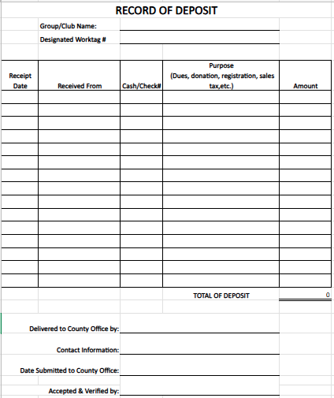
- Whenever possible, prenumbered receipts from official UADA receipt books should be issued to the person paying money to Extension. In no case should an unauthorized receipt book be used. If funds are collected from multiple individuals at an event, a list of people paying, how much they are paying, and the purpose of the payment can be attached to the Record of Deposit form and submitted along with the cash and/or checks in lieu of a receipt.
- When the volunteer brings in the cash and Record of Deposit form, they should have filled out the

- Group/Club Name
- Receipt Date
- Received From
- Cash/Check
- Purpose
- Amount
- Total of Deposit
- Signature of Person Delivering Form & Funds
- Contact Information
Rather than listing every receipt individually, an attached list may be submitted with a note to See Attached List. If the funds are the result of a public sale such as a plant sale, detailed recipient information may not be possible.
- Upon receipt in the county office, the money should be counted and reconciled to the amount reported on the form and remaining form information should be verified. If all receipts and documentation are in order, the County Administrative person should then sign and date the form. As shown below, receipts from the official receipt book should also be issued. This receipt should reflect the name of the person who brought in the money as well as an indication of the group whose account should receive the funds. The white copy goes to the volunteer or agent, the yellow stays with the money and the pink stays in the receipt book.

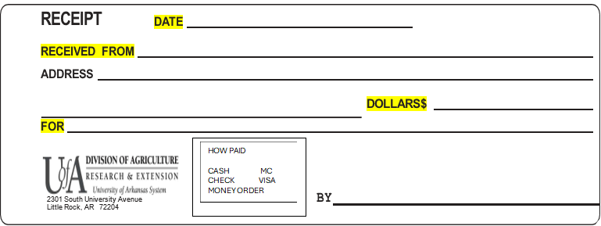

- Whenever checks are received in the county office, from any source, the back of the checks should immediately be stamped with a For Deposit Only stamp, if someone has not already done so. It is acceptable, and even preferable, to allow an agent or volunteer to have a For Deposit Only stamp at the site of an event or training, so checks can be stamped immediately and thus protected during transport to the county office.

Completing a Bank Deposit
- After the county office has received the monies from whoever brought it in, your next step is to complete a duplicate deposit slip from the UA System deposit book for your county. You will enter the date, record the currency and coin, and finally list the checks. Be sure to put the total dollar amount at the bottom of the deposit slip and always put the receipt numbers that are associated with that deposit.
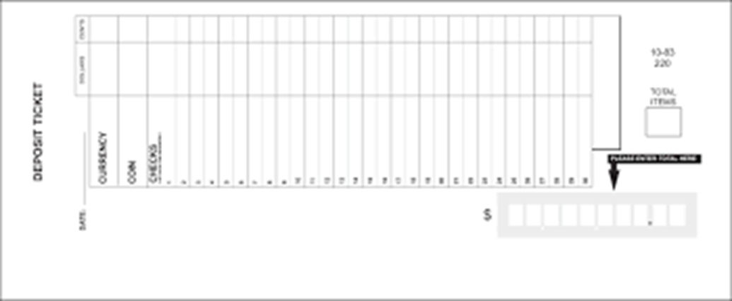

- Make a copy of the receipts, deposit slip, and all checks that are in the deposit and retain them in the office for recording in Workday. DO NOT MAKE A COPY OF THE CASH! Put the deposit slip (both copies), cash and checks in a money bag or envelope to be taken to the bank. Contact whoever is assigned to take the deposit to the bank and let them know it is ready to go and they will take it. You should not make more than one deposit per day.

- If for some reason the deposit cannot be taken to the bank immediately, it should be locked in a safe or file drawer away from the public until taken to the bank. Do not let money stay in the office over the weekend, and NEVER leave the deposit in an unattended vehicle.

- When the deposit is made, the bank will issue a receipted deposit slip that should be delivered to the county office. Make a copy of the bank imprint that is readable and use it along with other documentation from Step 7 to enter the deposit into Workday.

Entering a Cash Sale in Workday
- After the deposit is made it should be recorded as a Cash Sale in Workday, making sure that each Designated Account in Workday receives the appropriate portion of the deposit.
- Open Workday
- In the Search Bar in the middle of the screen type: Record Cash Sale
- Click the Record Cash Sale task from the search results.
- Your screen should look like the image below:

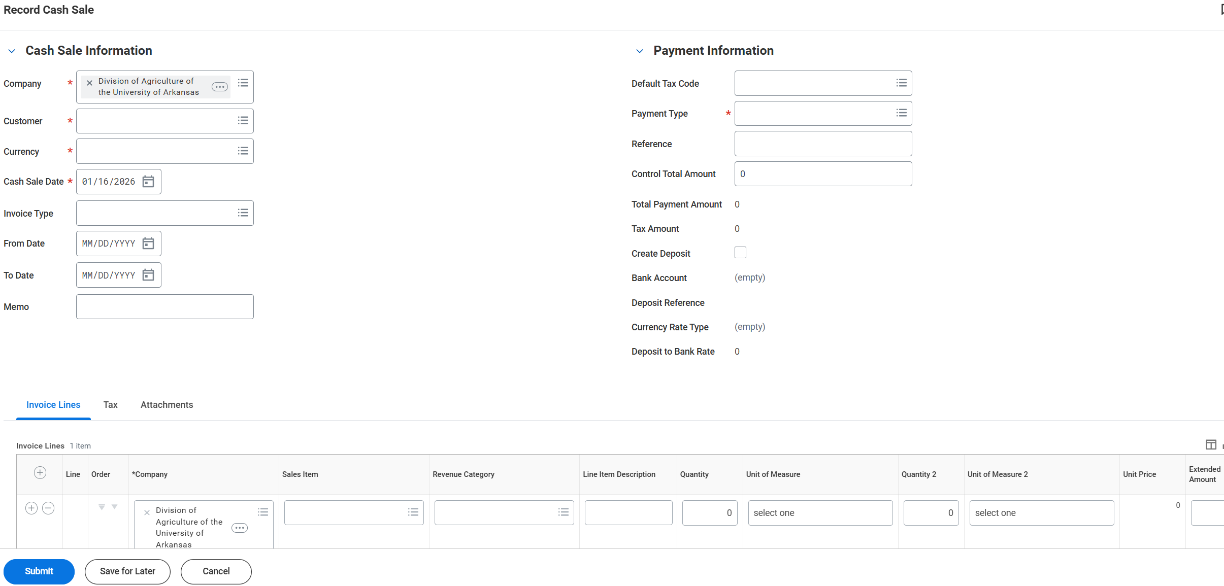

In the Cash Sale Information section:

Company: auto populate with UADA

Customer: (Your County) County Depository

Currency will auto populate to USD

Cash Sale Date: The date on the receipt from the bank. Note: If this is blank the transaction will not be included in the Cash Sale Transaction report.

Invoice Type: Leave blank

From & To Dates: Leave blank

Memo: Leave blank

In the Payment Information section:
Default Tax Code: Leave blank

Payment type: Manual

Reference: Leave blank

Control Total Amount: This is the amount of the deposit

Create Deposit: Click on box

Bank Account: Bank the funds were deposited. Entering your county name then <Enter> is a quick way to find your bank account

Leave all remaining fields blank.

In the Invoice Lines section:
Complete the fields shown in the following tables. Leave all other fields blank, unless instructed to use them for unusual transactions.
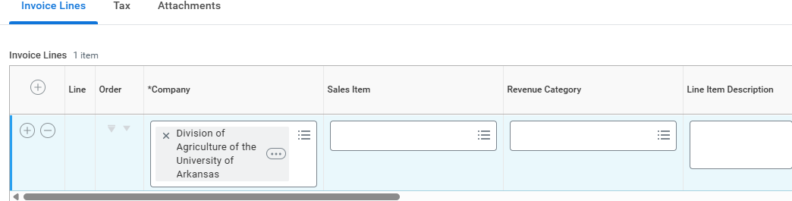
See Note Below
Company: Auto Populates

Sales Item: Leave blank

Revenue Category: Common codes are RC0005 for Contributions, RC0036 for Sales and Services, and RC0054 for money from your county 4-H Foundation. If you are unsure, call your District Secretary or another county.

Line-Item Description: Receipt #, What the money is, who brought it to you (it has to be in that order and have the commas, or it will be sent back). For example: 165123, 4-H kits for January, L Blevins

Note: When you have multiple receipts in a deposit you will need more than one line. To add additional lines, click in the circle with the + sign to the far left on the gray bar. You will have one line for each receipt in the deposit.

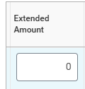 | 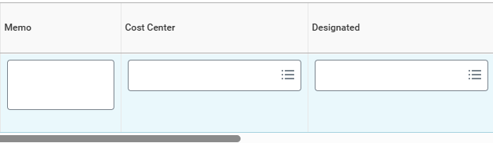
Extended Amount: The Amount of Deposit | Memo: Copy and paste what is in the line Item Description  Cost Center: Enter your county’s cost center  Designated: The DS# for the account to receive the deposit

- Next, all documents should be scanned and uploaded in the attachment tab. Documents include (in this order):
  - Copy of receipted deposit slip
  - Copy of original/unprocessed deposit slip
  - Receipts
  - All checks for each receipt and
  - Any other supporting papers (record of deposit, donation form etc...)

- Review the information and select Submit when you are sure it is correct. At this point, Workday will generate a note saying the transaction was sent to the Staff Chair and a CS # (Cash Sale #) is displayed. It is useful to record this number for future use, or the number can be obtained from the My Task area of Workday in the Archives section.

Next Steps
When the cash sale is submitted in Workday, it is routed to the Staff Chair for approval. If the Staff Chair approves, all transactions related to a county (CNTY) account are routed to the Fiscal Support Analyst for County Accounts. If approved, the transaction is processed and posted on Workday. In extremely rare occasions, a designated work tag NOT related to a CNTY account is appropriate. In those cases, the transaction will be routed to personnel responsible for that account
The Fiscal Support Analyst for County Accounts tracks and reconciles receipt numbers by county. If receipt numbers are missing, a Cash Sale Transaction Report will be generated to try to locate the missing receipt. If still unaccounted, the county administrative support person will be contacted for assistance. Often the receipt was voided, or the transaction was erroneously coded to a non CNTY account.

