Purchasing by Requisition and Receiving Goods
Version Date | October 2026
Policies & Resources | Travel Policy - UADA_380_1.pdf  How to Create a Requisition
Forms | All forms are built into Workday
Contacts | Purchasing@uada.edu; AccountsPayable@uada.edu
Related Guides | None

Introduction
There are several methods available when purchasing items for UADA operations, programs, etc. Typical methods, depending on the item and cost, include using a P-Card, T-Card, or Fuel Card, using a county check, using personal funds and requesting reimbursement, and creating a Purchase Requisition in Workday.
Most expenditures should be made by county office personnel creating a requisition in Workday and using the county cost center and appropriate worktag to designate where the expenditure is to be charged. (Purchase requisitions become purchase orders which are then sent to selected vendors for fulfillment.) Although virtually all purchases can be made with a requisition, small dollar purchases such as those for meeting refreshments and supplies can be made directly by issuing a county check or using a county p-card.
When purchasing items on state contract, authorized vendors must be used. If a purchase requisition is entered in Workday, the Purchasing department can ensure state contract compliance. Requisitions must be used for any equipment purchase. If a payment is needed to fulfill a contract obligation or Memorandum of Agreement (MOA), the payment must come from the state office.
This guide describes the process of creating a Purchase Requisition in Workday using a Workday-integrated "punchout" contract. In addition to the steps below, please consult How to Create a Requisition for non-catalog PO requisitioning.

Creating a Requisition

1. Log into Workday

2. In the search bar, type Create Requisition and select Create Requisition under Tasks and Reports.

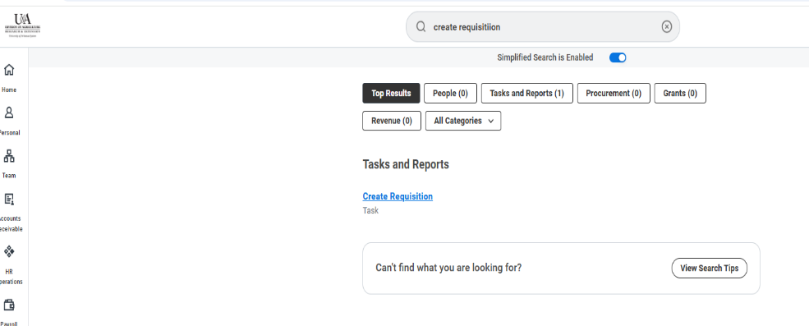

3. Complete the workday screen to start your requisition.

Field Name | Response
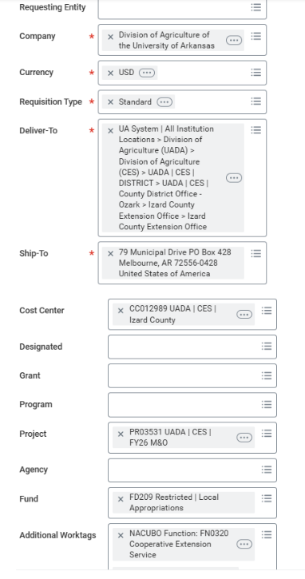 | - Requester – Auto Populates  - Requesting Entity – Leave Blank  - Company – Auto Populates  - Currency – Auto Populates  - Requisition Type – Standard  - Deliver-To – Auto Populates  - Ship-To – Auto Populates  - Cost Center – Auto Populates (double check to make sure it is the correct cost center)  - Designated, Grant, Program or Project need to be completed with information about what account you are charging for the purchase  - Agency is left blank  - Fund and Additional Worktags auto populate.  - Click the OK button

4. Under Create Requisition, select Connect to Supplier Website. Then choose the vendor option that applies to your purchase and click Connect beside the supplier you need.

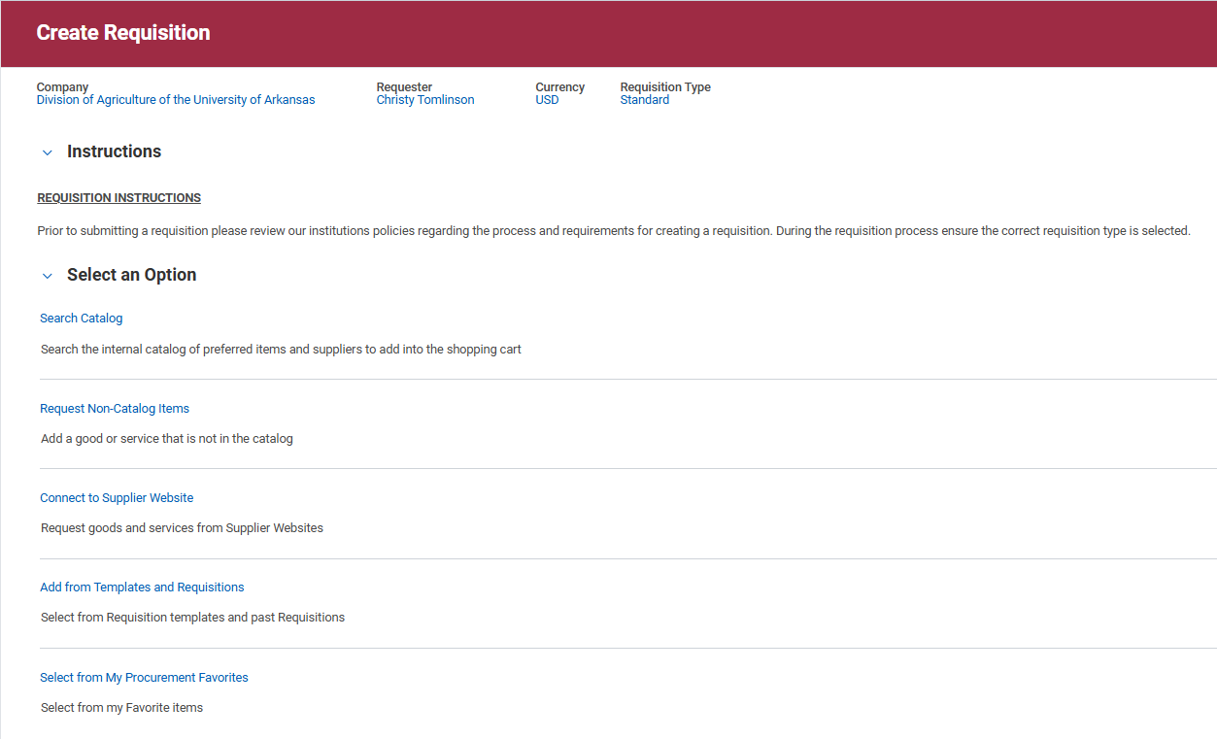

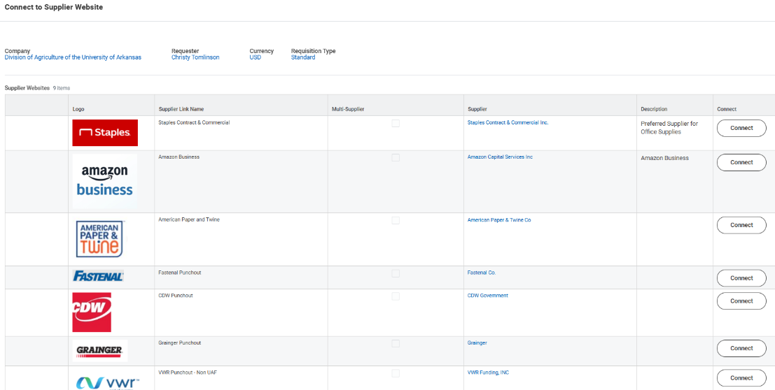

5. Shop on supplier website. Enter your office ZIP code, then click Continue.
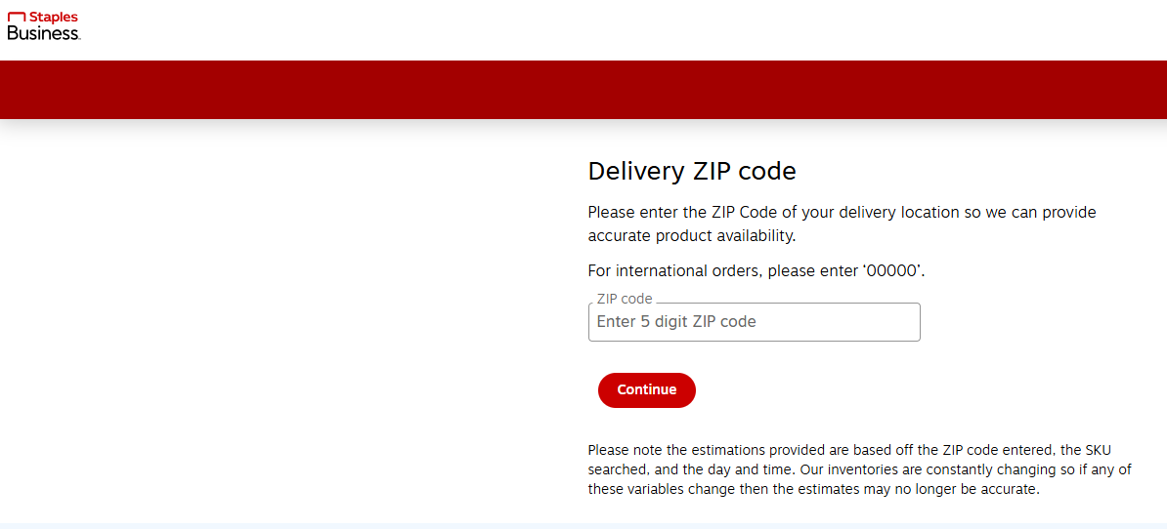

- Browse the supplier site and add needed items to your online cart. When all items are added, go to your cart for review.

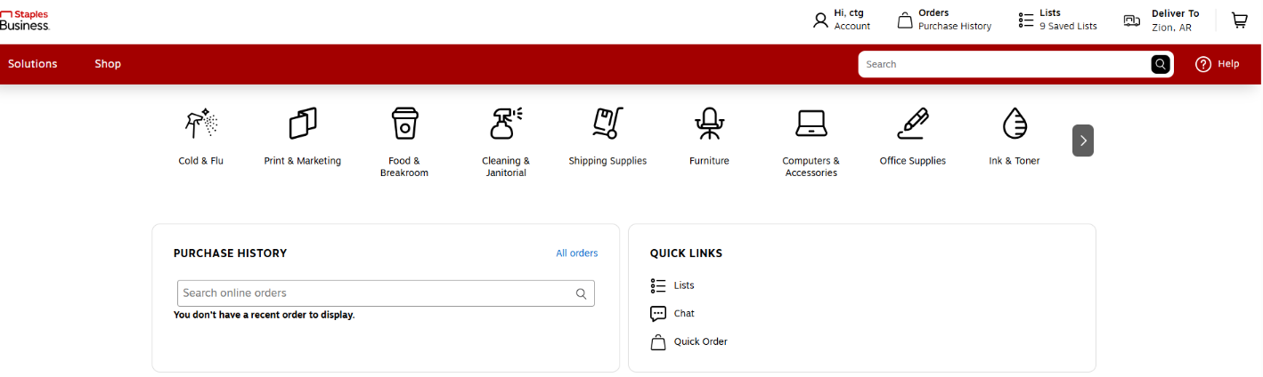
- Click Submit Order. Workday will automatically return you to a Workday screen showing the items you selected.

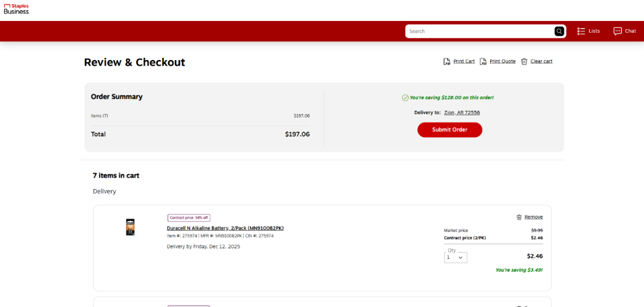
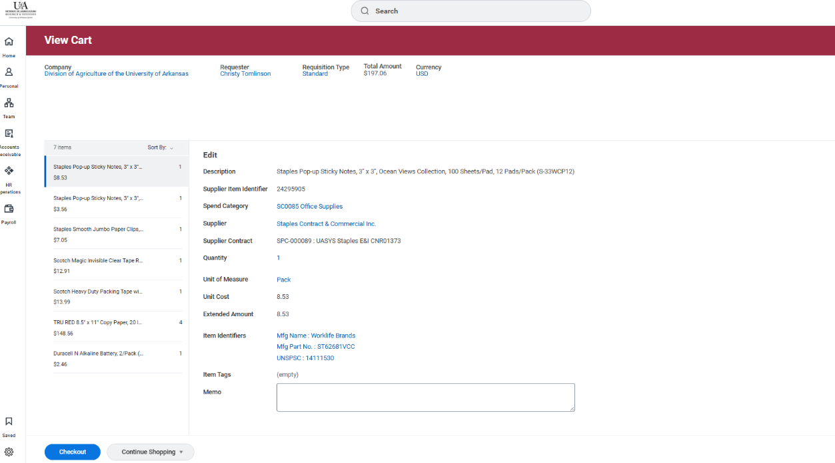

- Review Items in Workday. If everything is correct, click Checkout.

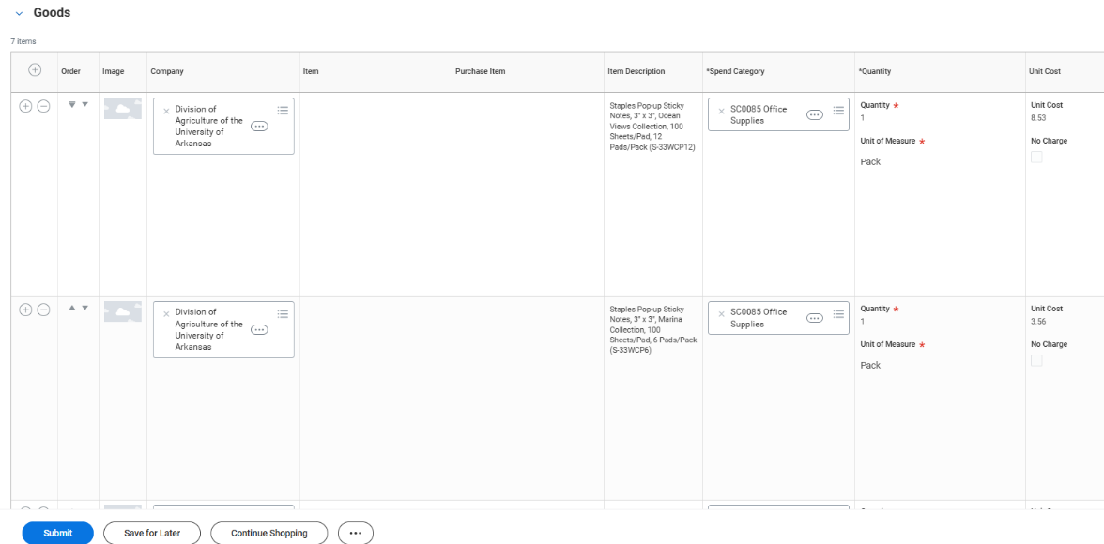
- Review all items again in the Workday cart. Ensure worktags, fund accounts, and costing information are accurate. Also, double check the Spend Category to make sure the default category is appropriate. If all information is correct, click Submit.

- After you have finished checking out/submitting, Workday will generate a Requisition Number.

- To go to the final approval step, click Next Step.
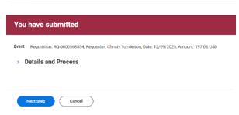
- Review the details one more time. Click Approve and you will receive an email message that your event was approved. The system will also provide a requisition number for future reference. It is a good idea to save the email or write the requisition number on supporting documentation, because this number is important for tracking and future reference.

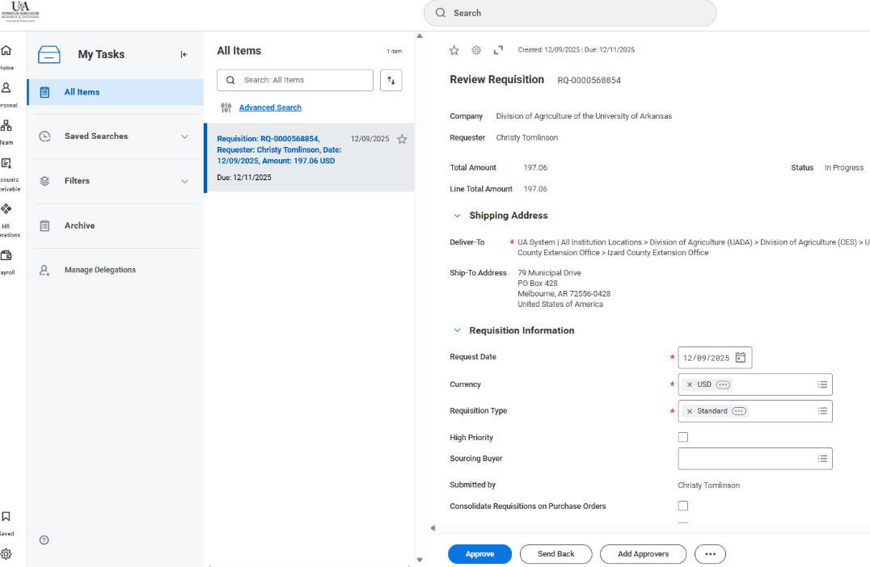
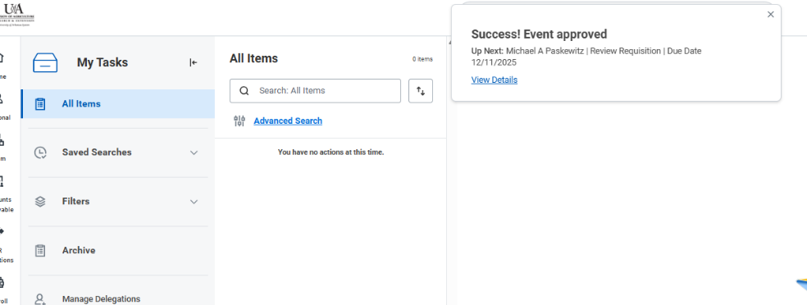

Receiving Goods
- After you have successfully initiated a Purchase Requisition in Workday, the document will be routed to your supervisor for approval. Depending on the type and amount of the purchase, additional approvals may be required. When all approvals have been acquired, a Purchase Order will be sent to the vendor, and you will receive a notification called Supplier Account Match Event for Supplier Invoice (with Invoice number) when goods are shipped.
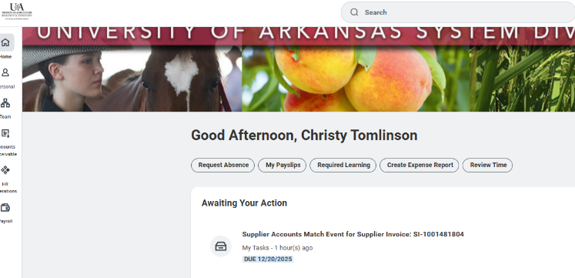

- Notice the SI (Supplier Invoice) number provided in the red circle below. You may want to save that number in case you need to verify payment status and/or details later; however, there are other ways to find the number if you do not save it. Then, select Supplier Accounts Match Event for Supplier Invoice # . . . . and Workday will take you to the Create Receipt for Purchase Order screen.
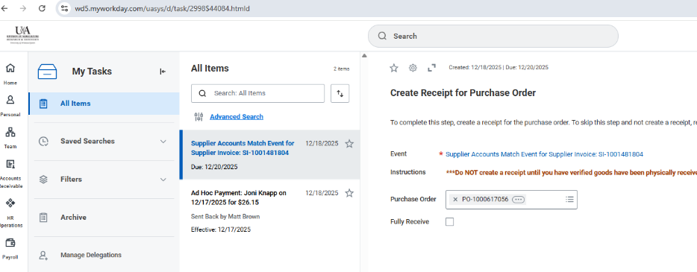
- After receiving ALL items purchased you can click on Fully Received and then Submit.
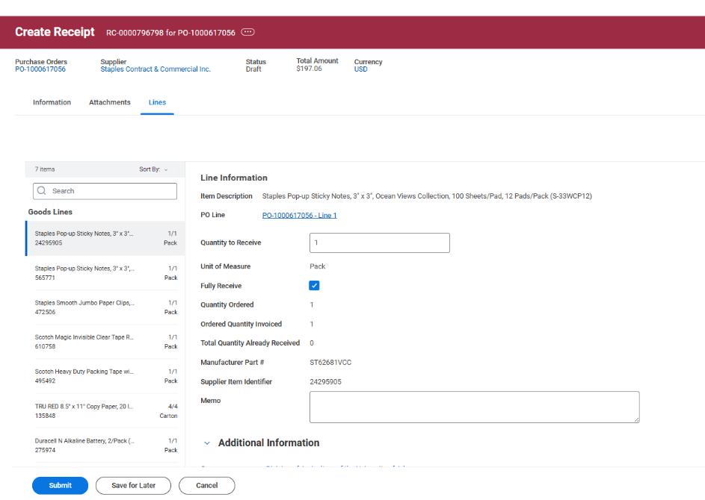
- Make sure the Fully Received box is checked on each item and then click Submit. You will receive a receipt # that is tied to the purchase order created based on your original purchase requisition.
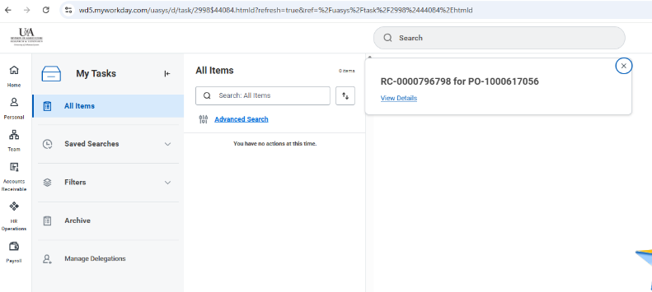

- While it is possible to denote partial receipts by entering the actual quantity received by line item, it is preferable to wait to complete this screen until all items are received. If you believe some items will not ever be received, contact AccountsPayable@uada.edu for instructions.
Note: It is critical that Submit be selected at the bottom of the Create Receipt screen. Failing to do so means that no further processing of the transaction will occur, including paying the vendor. Failure to pay the vendor timely can result in a violation of payment terms and result in late fees.

Next Steps
When the goods ordered have been received and entered in Workday, a system match of pertinent information will be performed. If all information matches, the vendor payment will be approved. At this point an expense and liability (Accounts Payable) will be created in workday and the expenditure will be included in the RPT – Balance by Designated report. Finally, Cash Management will run the payment job which triggers a check or electronic payment to be sent to the vendor.

