Private (Pesticide) Applicator Training
Version Date | August 2026
Policies & Resources | UADA Pesticide Training Web Page  County PAT Resources (from LRSO PAT Office)
Forms | Attendance Record (PCT-04.1)  FIN-216C Transfer Request Form
Contacts | PAT@uada.edu
Related Guides | Receiving and Depositing Funds; Creating and Using ISDs

Introduction

County Extension Offices assist eligible clients in obtaining Arkansas Private Applicator Training (PAT) Certification, a requirement for state licensing. Private Applicator Training certification is intended for individuals who apply restricted use pesticides in the commercial production of agricultural commodities on their own farm or the farm of their employer.

To qualify for PAT Certification, applicants must:
- Be involved in the commercial (for sale) production of agricultural commodities on their own farm or the farm of their employer.
- Use or intend to use restricted-use pesticides as part of their agricultural operation.
Home gardeners and individuals not engaged in commercial agricultural production are not eligible for a Private Applicator Certification.
Note: UADA counties are not involved in commercial pesticide application licensing! Commercial applicator training is handled by the Little Rock State Office.

Licensure
Licensing may be initial or renewal and for one year or five years, although some restrictions apply.
Obtaining a license is a two-step process. (1) The candidate must be certified through training. Training options include online training or in-person training. (2) The candidate must apply and be approved for a license by the Arkansas Department of Agriculture.

Online Training (Self-Paced). Applicants who prefer to complete training independently may do so online through the UADA website. Steps include:
- Complete the Dp-25 Private Applicator - Application Form.
- Create an account for the Arkansas Private Applicator Online Training Course using the Create Account link below the red Log In button in the top left corner of the screen.
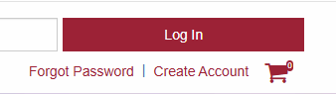
- Follow the instructions provided by the Arkansas Department of Agriculture to complete the licensing process.
Questions regarding the licensing process should be directed to:
Arkansas Department of Agriculture
Plant Industries Division – Pesticide Section
Email: pesticide.private@agriculture.arkansas.gov
Phone: (501) 219-6314

Option 2 – In-Person Certification. In-person certification is administered by the County Agriculture Agent through a scheduled classroom training. Applicants may find training through the UADA Events Calendar or by contacting their local County Extension Office for upcoming training opportunities.

Fees

Extension Service training fees for both initial certification and recertification are $20.00 per person. This fee covers the Extension training only. Applicants are also responsible for paying the required licensing fee directly to the Arkansas Department of Agriculture, Plant Industries Division – Pesticide Section.

Training Documentation

On the day of Training, the Extension Ag agent in charge of the PAT program will collect the $20.00 training fee, an attendance sheet with signatures, and the Arkansas Pesticide Applicator Training Verification Form that is signed by the applicant and Ag Agent. This form can be ordered by contacting LRSO Facilities Management.
After the Training Verification Form has been completed and signed:
- Pink Copy: Given to the applicant as proof of training.
- Yellow Copy: Retained in the County Extension Office for office records.
- White Copy: Submitted to the Arkansas Department of Agriculture, Plant Industries Division – Pesticide Section.

Deposit of Training Fees & Notification to Arkansas Department of Agriculture

Following the training, the County Administrative Assistant will prepare and submit the deposit for all training fees collected. When entering the deposit into Workday, attach the following documentation:
- A copy deposit slip.
- Copies of all checks received.
- Copies of all receipts issued for the $20.00 training fee. (Individual receipts or one receipt for all to the agent.)
- A copy of the signed attendance sheet (below).
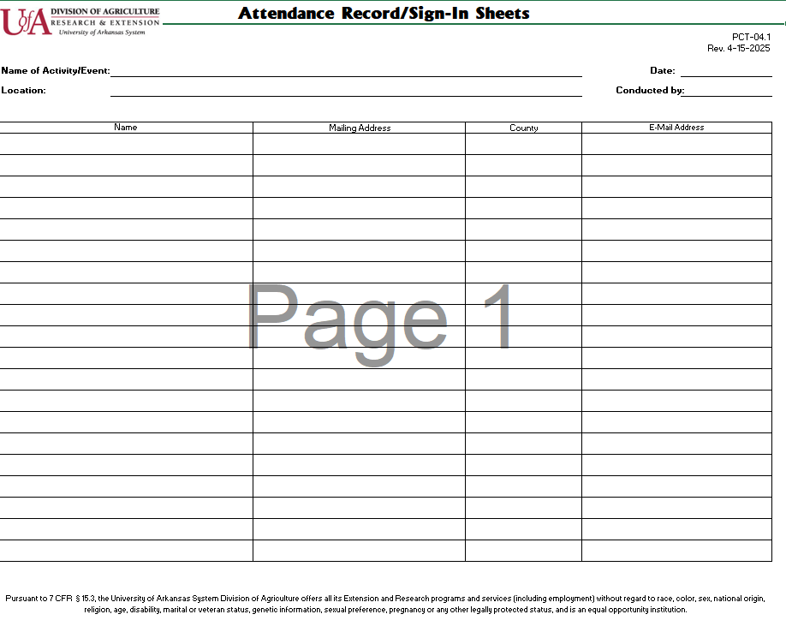
After the deposit has been completed, the County Administrative Assistant or County Agriculture Agent will promptly email the white copies of the Arkansas Pesticide Applicator Training Verification Forms to the Arkansas Department of Agriculture, Plant Industries Division – Pesticide Section at pesticide.private@agriculture.arkansas.gov.
Once the Department of Agriculture receives the email, the Department will send instructions and an invoice for the license fee to the applicant. It is then the applicant’s responsibility to return the paperwork and the fee to the Arkansas Department of Agriculture, Plant Industries Division Pesticide Section. Licenses are typically received within 14 business days. License Search can be used to check status of the license application.
Note: The Department of Agriculture no longer mails a hard copy license to the applicant. Applicants much check their email to find their license.

Transfer of Training Fees

Using the participant log, a FIN-216C Transfer Request Form should be completed to transfer the deposited training fees to the appropriate account. (The LRSO PAT Program receives ½ of the training fees and the county keeps ½ of the training fees in its depository account.) The timing and frequency of completing the FIN-216C can vary. If you do not have PAT classes frequently you may choose to make the transfer every time you do a class. If you have several throughout the year it may be easier to maintain a spreadsheet throughout the year and submit the Transfer Request Form annually.

When completing the FIN-216C,
- Make sure to include the reason for transferring (1/2 the funds received for PAT training are to be transferred to the LRSO PAT Program).
- Attach copies of the sign-in sheets – Make sure the number of attendees matches the amount of money being transferred.
- Do not include receipts, triplicate copies, or promotional materials. Financial Services will send the request back if it includes anything extra.
- The workday fund and call center numbers you will be transferring to are Cost Center: CC013057 and Designated Work Tag: DS03506
- Fin-216C form needs to be signed by the County Staff Chair in the Financial Manager of “From” Source and dated.
- Email the forms to PAT@uada.edu for ISD completion in Workday.

When the FIN-216C is submitted to PAT@uada.edu, PAT program personnel will enter an Internal Service Delivery transaction in Workday. The transaction will then be routed to the County Admin for approval before being routed to the Business Office. The Business Office usually approves and completes the transaction within about a week. When all approvals are entered in Workday, the transfer will post and the funds will be transferred.

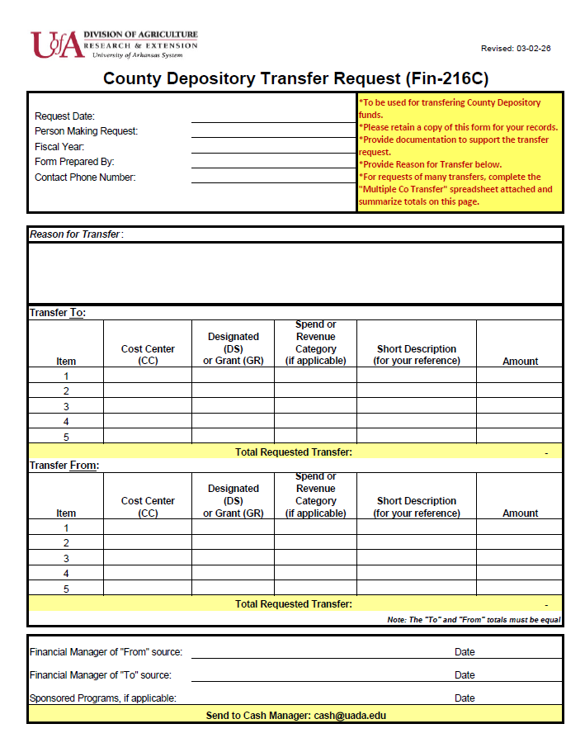

Next Steps
Other than documentation included with the deposit, there is no paperwork or notification required of the county by the University of Arkansas Division of Agriculture. Also, the county office does not control the awarding of licenses. If an applicant has a problem with the license, they should contact the Arkansas Department of Agriculture. Finally, as discussed above, at least by the end of the fiscal year, half of the training fees collected should be transferred to the LRSO PAT Program via a Fin-216C.

