County 4-H Poultry Auction Revenue
Version Date | October 2026
Policies & Resources | None
Forms | Poultry Auction Revenue Form; Gift Disclosure Form – UADA (Workday)
Contacts | Cash@uada.edu; DevelopmentOffice@uada.edu
Related Guides | Receiving and Reporting Gifts

Introduction
The Arkansas 4-H Poultry Chain is a youth agricultural project that gives 4-H youth hands-on experience in poultry management, showing, and business skills. Because it is a low-cost, minimal space program designed to be accessible to youth regardless of where they live, it is a very popular program. 4-H members are given (or purchase) up to 25 chicks in the spring that they raise. Some of the poultry are shown at the county fair and possibly the district and state fair.
Although program rules vary between counties, 4-H youth are generally required to offer four pullets for sale at an auction held during the county fair with the proceeds going to the county 4-H program. In some counties, the auction is conducted by the fair association. In other counties, County Extension personnel conduct the auction.
This guide describes the recommended procedures when County Extension personnel conduct the auction with proceeds going to support the county 4-H program. This involves completing the Poultry Auction Revenue Form and possibly one or more Gift Disclosure Forms.

Poultry Auction Revenue Form
On the day of the auction, complete the Poultry Auction Revenue Form as described below.

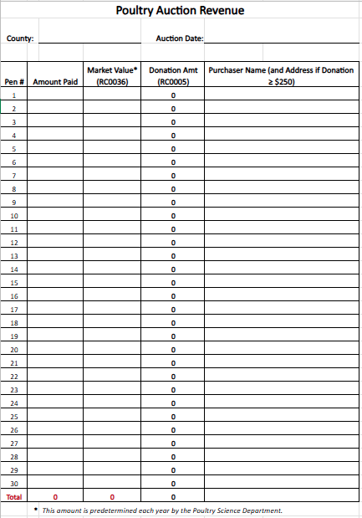 | - Enter your county name and the date of your 4-H auction.  - Enter the market value of each pen, based on the predetermined value for that year’s auction. If you do not know this amount, contact our Poultry Youth Specialist or your District Director. In most cases, chickens are sold four to a pen. Therefore, multiply the per-chicken value provided by four before entering the amount in the form. If for some reason there is a different number of chickens in a particular pen, adjust the market value of that pen accordingly. Note: For UADA purposes, all chickens are valued at the same amount, regardless of whether they have won awards.
- Until the Amount paid is entered, the Donation Amount will appear as a negative of the Market Value. This is due to the formula programed into the Donation Amount Column.

- As pens are sold, the sale amount, name of the purchaser, and pen # should be entered on the form. If any purchaser pays a price that results in a Donation Amount of $250 or more, the purchaser’s address should be recorded. If the form is completed manually, when the auction is over the information should be entered into the electronic form. The form is designed to automatically calculate the Donation Amount, as well as totals for the Amount Paid and Market Value.

- When the Amount Paid is entered, the correct amount of the donation should automatically be calculated. If the Amount Paid is lower than the Market Value, the Market Value will need to be changed to reflect the Amount Paid. The Donation Amount will be zero (0).

- If the Donation Amount is a negative number, then you will need to replace the negative number with a zero (0). A negative number cannot be left on form.

- If someone buys a pen, does not take the chickens, and the birds are resold, enter zero (0) in the Market Value column for the original purchaser and the actual Market Value for the second purchaser who actually takes the chickens. The idea is that the Market Value of the chickens should be entered once and only once on the form, no matter how many times they are sold.

- Individual, official receipts are not required to be given to each purchaser. However, whomever collects the money on the day of the event should turn it over to county personnel for deposit. Then, one receipt for the total amount of the proceeds will be given to the person turning in the money.

- If any purchaser wants a tax receipt for the amount of their donation, follow normal donation procedures. If the donation is less than $250, a thank you note from the County office is sufficient. If the donation is $250 or more, a Gift Disclosure Form should be completed for the donor/donation. Otherwise, complete ONE Gift Disclosure Form for the entire poultry auction revenue as shown below.

Note: When depositing the proceeds of the auction, make sure total market value is coded as Educational Sales and Services, and the total donation amount is coded as a Gift.

Gift Disclosure Form
Complete the collective Gift Disclosure Form as shown below.
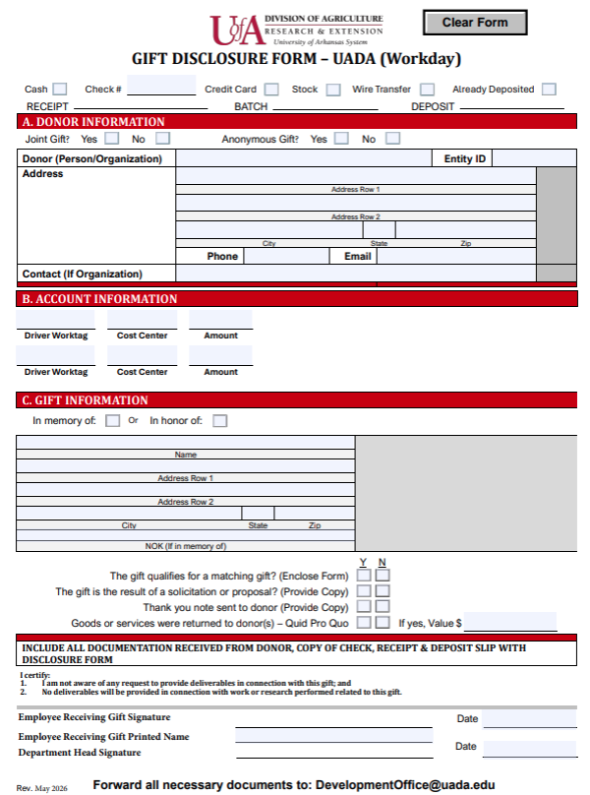 | Header:  Check the box for “Already Deposited”
Section A:
For Donor, write “Poultry Auction”

For Contact, put “See Attached Form”
Leave other fields blank

Section B:
Complete fields based on how the proceeds were deposited.

 | Section C: Leave blank
Signatures:
The Employee Receiving Gift Signature can be left blank.

The Staff Chair should sign as the Department Head.

The Gift Disclosure Form should be emailed to the Development Office with a copy of the completed Poultry Auction Revenue form. The two completed forms should also be included in the Cash Sale transaction documentation. Finally, it is recommended that a copy of both forms be retained for your records.

Next Steps
As discussed more fully in the Receiving and Reporting Gifts process guide, the Development Office is responsible for providing IRS-acceptable tax receipts to donors. Furthermore, in the UADA gift database, all poultry auction donations will be credited to the county and 4-H program that generated them.

