Purchasing, Using, and Reporting Postage and Supplies (Stamps.com)
Version Date | August 2026
Policies & Resources | C.E.S.P. 11-6: Postage Guidelines  C.E.S.P. 11-7: County Office Bulk Rate Mail Usage  C.E.S.P. 11-9: Mailing List Revision  Postal Application - Intellistack  Stamps.com Login
Forms | No Official Forms
Contacts | For access to the UADA Stamps.com account, contact Purchasing@uada.edu  For questions, issues, or to update cost codes, contact Postage@uada.edu or Purchasing@uada.edu
Related Guides | No Official Related Guides

Introduction
UADA made the decision to move to Stamps.com in about 2022. This service offers more flexibility for multiple locations and is more streamlined from an administrative standpoint. Stamps.com is also very user-friendly. The remainder of this guide explains the steps for adding and using postage as well as ordering supplies through Stamps.com.

Adding (Purchasing) Postage
- Log in to Stamps.com with your credentials (If you need access/credentials, contact Purchasing@uada.edu.
- Go to the top right side of the screen where the amount of current postage available is listed as shown below and hover your mouse over the amount to generate a list of options and select “Add Funds.”.
Available Postage | Option List
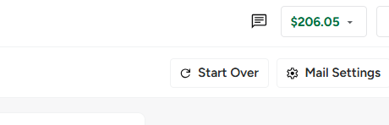 | 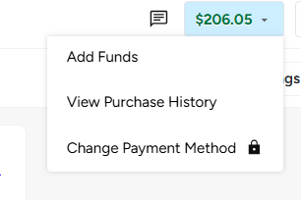

- Choose the amount you want to add from the list or enter the desired amount in the Other option space and select Purchase.

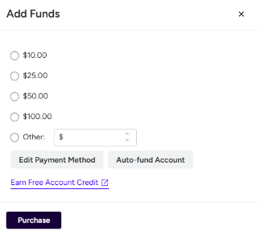

- You should then receive a “Transaction Complete” message. Click OK.

Using Postage
- Stamps.com allows you to print stamps to place on letters or small envelope as well as labels for shipping packages. To generate stamps or labels, log in to Stamps.com with your credentials and select the Mail option from the top menu.

- To print stamps/postage to mail a letter or envelopes between 3 ½’ x 5’ x .007” thick and 6 1/8” x 11 ½” x ¼” thick, complete the required fields as shown and discussed below.

Required Fields for Mailing Letters
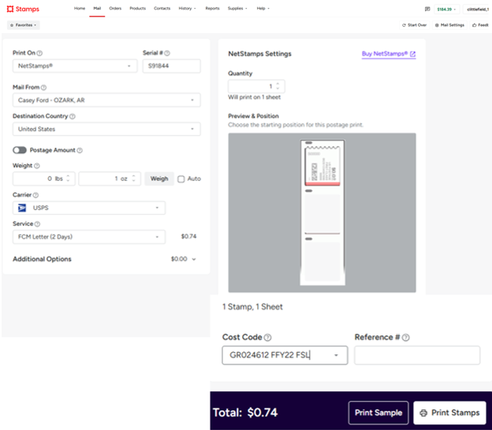

Field | Response
Print On | Select what print media you want such as NetStamps (Roll) for stamps to mail a letter.
Serial # | If you select NetStamps, you will need to supply the Serial # from the roll of stamps you will use in the printer. This will ensure the stamps print correctly on your Onyx stamp printer.
Mail From | Select your Staff Chair’s name from the options list.
Destination Country | United States will default.
Weight | Weigh your item and enter the amount in pounds and ounces. Note: Use Auto only if you have scales connected to your computer.
Carrier | USPS will default.
Service | Select what you are mailing from the drop down list. For example, to mail a letter, select FCM Letter-1Day. If mailing anything other than an envelope, the package dimensions will be required.
NetStamps Settings | Enter the number of stamps you want to print. (NetStamps labels come on a pre-printed sheet of 25 per page.)
Preview & Position | This shows you where the stamp will print on the page and allows you to change the position.
Cost Code | Select the appropriate Fund/Worktag from the options presented. If the needed choice is not listed, contact Postage@uada.edu or Purchasing@uada.edu to have it added.
Reference # | Entering anything here is optional. However, you may want to enter such information as the club name, if applicable to help identify the charge later.

- To print shipping labels for packages, complete the required fields as shown and discussed below.

Required Fields for Mailing Packages
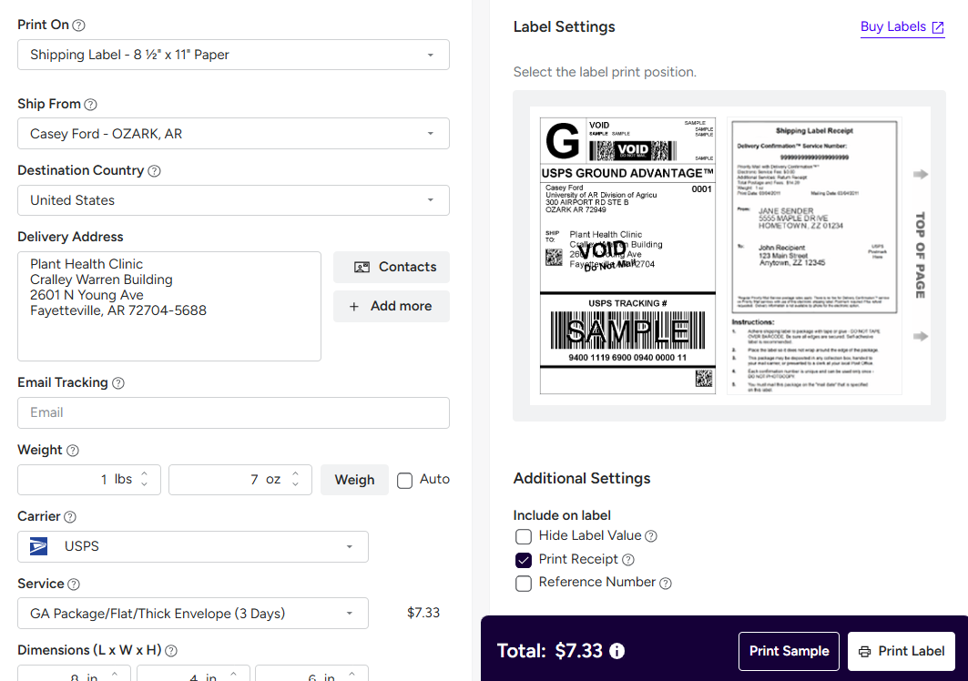

Field | Response
Print On | Select Shipping Label for boxes or large envelopes.
Ship From | Select your Staff Chair’s name from the options list.
Destination Country | United States will default.
Delivery Address | Enter recipient’s address.
Email Tracking | Enter your email address to receive an email tracking link.
Weight | Weigh your item and enter the amount in pounds and ounces. Note: Use Auto only if you have scales connected to your computer.
Carrier | USPS will default.
Service | Select Ground Advantage (3-day delivery and about ½ the cost of Priority) or Priority Mail (1-3 day delivery)
Dimensions | Enter dimensions in inches as follows: L x W x H
Label Settings | An image of the label will appear, and you have the option of repositioning it.
Additional Settings | There are several options for information to include on the label. If you need a receipt for shipping cost, select Print Receipt. You will need to load the correct label (Avery 27900 – Shipping Label with Paper Receipt). This is a full-sheet form. It will print the label on ½ sheet and receipt on other ½ sheet. The receipt will contain all tracking information as well as postage cost. If you do not need the Receipt portion, you might use a half-sheet label which will only include the Ship To and Sender info as well as the cost.
Print Sample/Label | When ready, select Print Label.
Cost Code | Select the appropriate cost code from the options provided.

- Reprinting: If you get an error or forget to load the correct media (envelope, label, etc), you can reprint the postage without being charged twice. Once the first print process has been completed, an option will appear at the top of the page to “Reprint Postage.” Load the media, then click that button (Reprint Postage) to print again. DO NOT click Print Stamp/Label again! This will result in a second billing.

Ordering Supplies
- After you log in to Stamps.com, from the menu across the top of the home page, hover over Supplies and a drop down menu appears.
- Click on the item(s) you need to order from the list. When all items have been selected and your cart reviewed, click Checkout. | 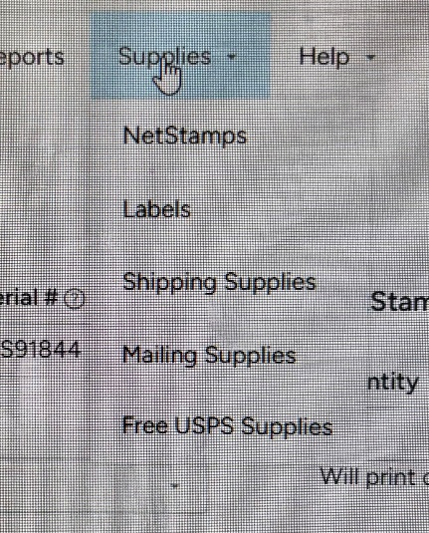

- After selecting Checkout, a screen will appear with all your delivery information and an order summary, as well as payment information. First, confirm your shipping address as shown below then select Continue to Shipping.
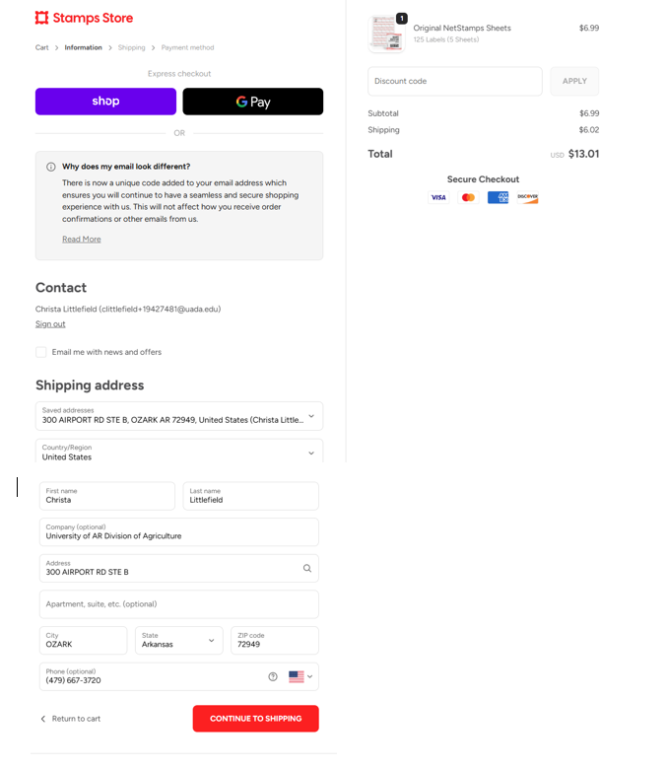
- Select a shipping method from the options presented and click Continue to Payment as shown below.
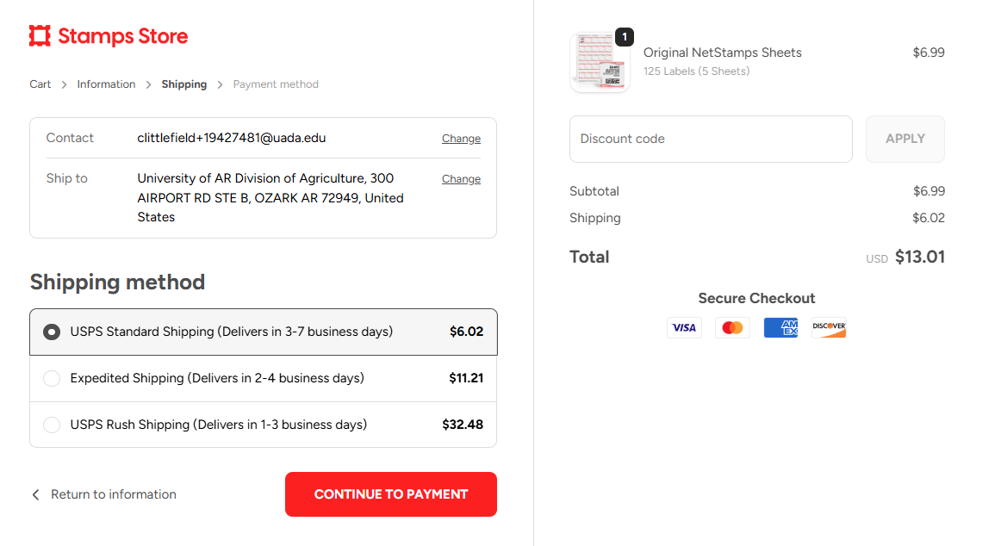

- Select Payment Method / Saved Payment Method / Invoice as well as Billing Address: Same as shipping address and click on Pay Now.
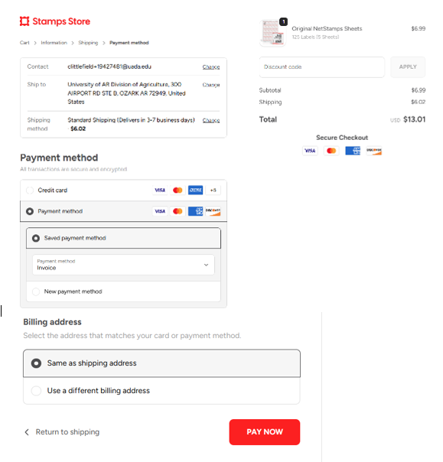
If standard shipping was selected, you should receive your order in 3-7 business days.

Reporting Postage
County personnel are not required to report postage purchases and/or usage. The Business Office will download reports from Stamps.com monthly and post the information in Workday by cost center. No further action is required by county staff.

