P-Card Usage and Transaction Verification
Version Date | October 2026
Policies & Resources | UADA P-Card Resources; Credit Card Matrix; P-Card User Manual; Gift Card Procurement Resources
Forms | P-Card Receipt Form; Official Function Form; Affidavit of Lost Receipt
Contacts | pcard@uada.edu; purchasing@uada.edu or the Procurement Office at 479.502.9701
Related Guides | None

Introduction
The purpose of a Purchasing-Card (P-Card) is to provide employees with a convenient method for making low-dollar, business-related purchases in the normal course of conducting research, programs, or administrative tasks on behalf of UADA. UADA-issued P-Cards are not intended to replace traditional purchasing methods for high-dollar transactions, nor are they to be used to circumvent State of Arkansas procurement laws or UADA procurement policies and procedures.
This guide describes the use of p-cards, transaction documentation requirements, and subsequent verification of the purchase transactions.

P-Card Purchase & Required Documentation
Most county agents have a P-Card. If one is needed, a request may be submitted through the Workday task: Create Request. Cards are then activated online as described in Section 4 of the UADA P-Card User Manual. P-cards have established limits, based on the employee’s position. However, higher limits may be requested. In addition, one-time exceptions to the regular limit can be requested.
P-Cards may be used for a variety of purchases. However, per the UADA P-Card User Manual, the listed below are NOT allowed. You may also consult the Credit Card Matrix for additional information about allowability of charges.
- Airfare, Lodging, Car Rental, anything related to travel
- Alcoholic Beverages
- Any purchase that would involve a trade-in
- Cash advances or gift cards (refer to UADA Gift Card Procurement resources)
- Fuel- Gas can only be purchased using the Wright Express (WEX) Fleet Card
- Contracted services requiring a signature
- Some State contract items (for questions concerning what is considered a State Contract item, contact Procurement Office).
- Personal Purchases or Gifts
- Purchase of tires, unless approved by the Procurement Manager
- Drinks for field workers should only include water and/or electrolyte drinks. Purchase of any other type of beverage will result in reimbursement of the item(s).
- The purchase of flowers.
- Printing Services (Amendment 54: “Wet ink on paper”)
- Software and Cloud services – these purchases require an IT approval form and must be included with the transaction in Workday.
For each charge made to a UADA P-Card, the cardholder is responsible for obtaining adequate documentation and providing proper support for the purchase of goods or services. All receipts must be merchant-produced. Examples include:
- A receipt and/or transaction slip from the merchant.
- An order form
- An invoice showing credit card payment.
- A packing slip from the delivery annotated by the Cardholder as ordered by, received by, paid by and signature of the Cardholder.
If receipts are lost, the Cardholder should contact the merchant and attempt to obtain a duplicate receipt. If that is unsuccessful, an Affidavit of Lost Receipt may be completed to serve as an ad-hoc receipt.
Required information sourced from one of the documents listed above includes:
- Date of purchase
- Description of items purchased
- Quantities
- Itemized amounts
- Total charge amount
- Merchant name and address
In addition to the itemized receipt, the following documentation is required to be submitted in Workday as part of the verification process.
- P-Card Receipt Form (required for every p-card purchase) signed by the employee who made the purchase.
- Official Function Form (required when food or beverages are purchased for immediate consumption), signed by the requestor and the requestor’s supervisor.
- If an Agent is the requestor, the Staff Chair must sign as the supervisor.
- If the Staff Chair is the requestor, the District Director must sign as the supervisor.

Verifying Procurement Card Transactions
When purchases are made with a P-Card, transactions must be verified in Workday. Verification must be completed by the ﬁfth business day of the following month, but weekly verification is recommended.
- Log into Workday and in the search bar, start typing “verify procurement card.” Several choices will appear. Click on the Verify Procurement Card Transactions for Worker task.

- In the Veriﬁcation For field, type the agent’s name. Set the Document Date to the end of the month in which the p-card was used. After the information is entered, then click the OK button.

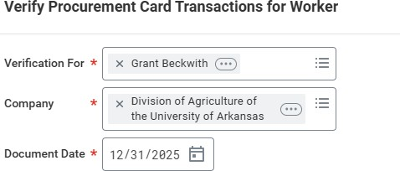

- Select the p-card transaction you would like to verify (or Select All) and then click on the OK button at the bottom of the screen.

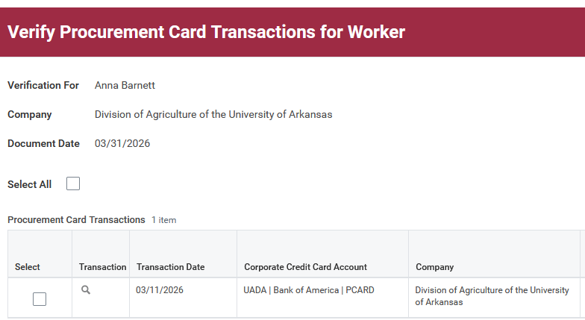

You should see a screen like this: 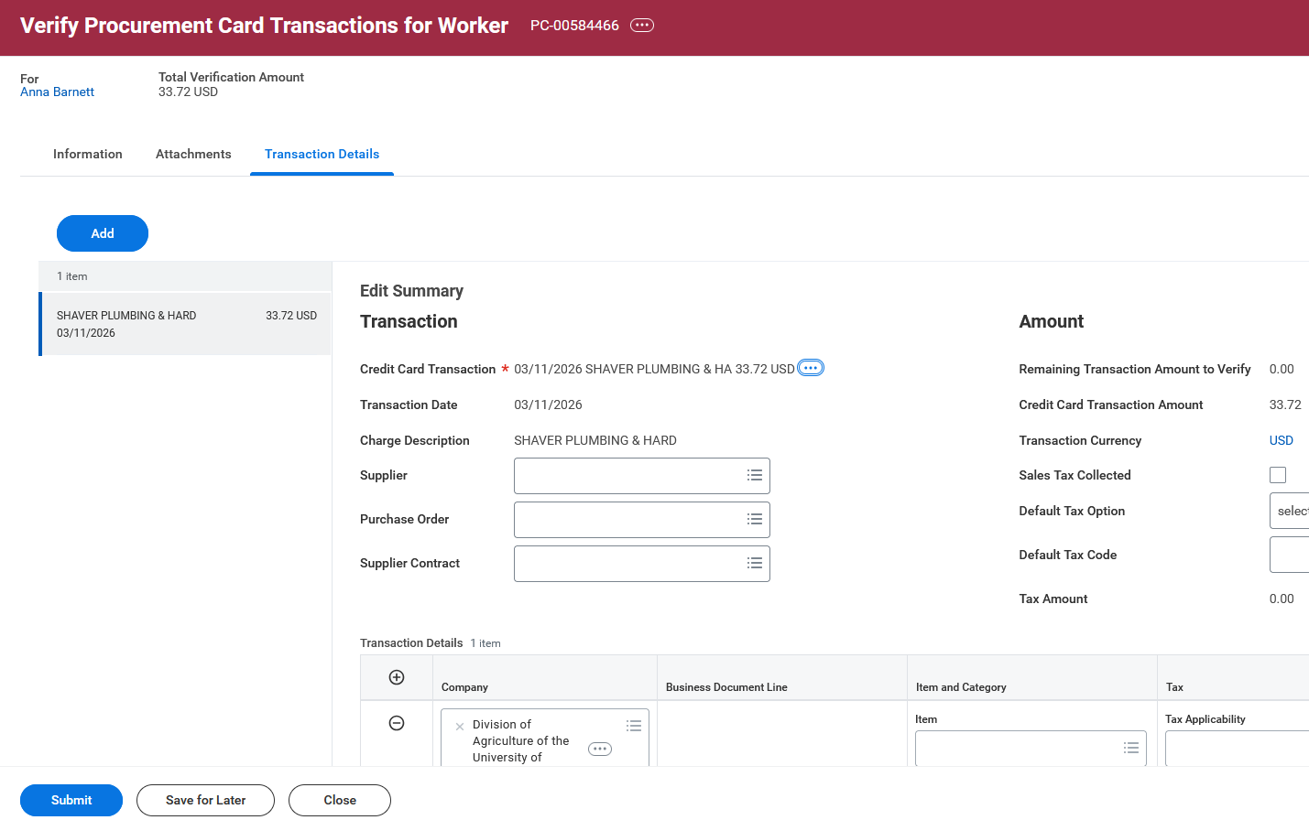

- The Document Date needs to be within the same month as the transaction date. If the transaction date is at the end of the month and verification is started after the first of the next month, the Document Date in the Information section should be changed to the last day of the transaction month. To change the date, select the Information tab, select Edit, and then change the Document Date. Then click Save. (Do not Submit.)
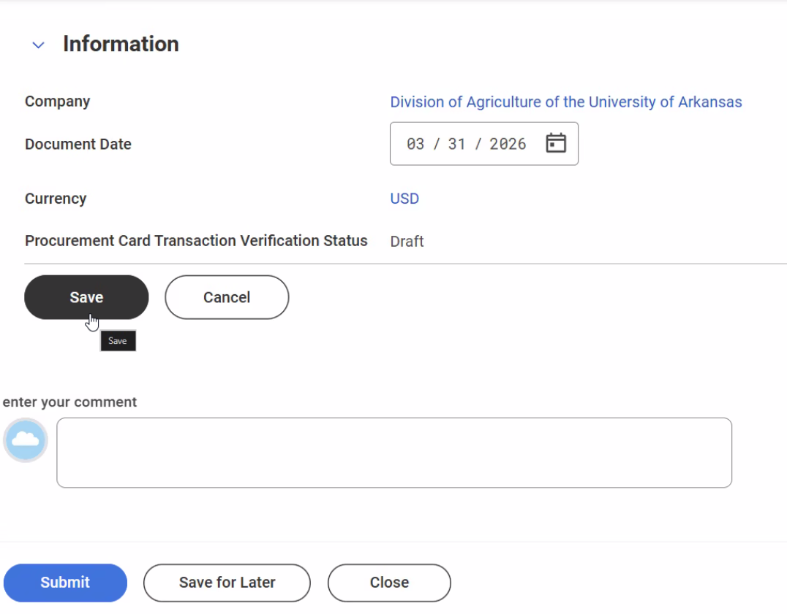
If necessary, change to last day of transaction month.

- Select the Transaction Details tab. Under the Amount section on the right-hand side of the screen, check the Sales Tax Collected box if sales tax was charged on the receipt. If the receipt does not include sales tax, leave this box blank. Finally, if sales tax was not collected and the purchase is taxable, then select Calculate Self-Assessed Tax from the dropdown menu next to Default Tax Option.

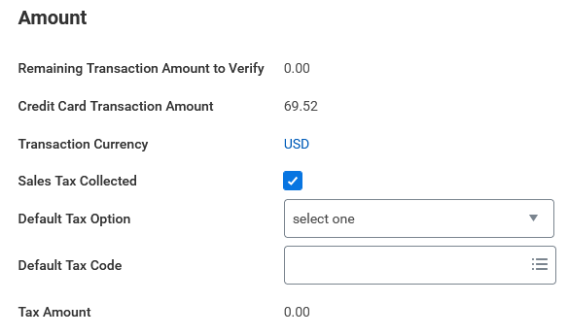

- With the Transaction Details tab selected, go to about the middle of the screen. As you work through these fields, you may need to scroll right to reveal all the columns. To make the scroll bar appear, hover your mouse over the bottom of the blue band.

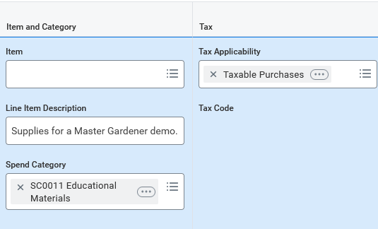 | 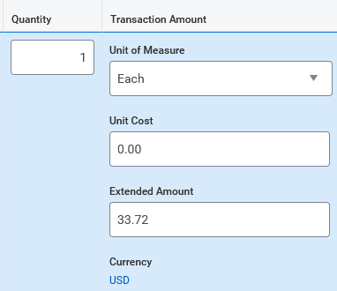
- In the Item Category column, skip Item and complete the Line Item Description field by entering a description of what was purchased.  - Choose a spend category that is appropriate for the item purchased. (A list of Spend Categories can be found on the UADA website.  - Tax Applicability should be auto populated according to what spend category was selected. | - In the Quantity column, choose One.  In the Transaction Amount column (heading):  - Choose Each for Unit of Measure  - Skip Unit Cost  - If it does not auto populate, enter the amount of the p-card charge under Extended Amount

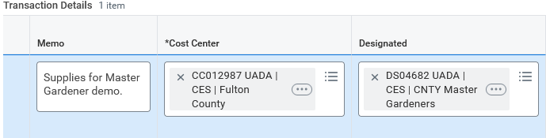

- In the Memo field, put the same information that was entered in the Line Item Description, along with any additional details that are important for understanding the nature of the purchase.
- The Cost Center will auto populate based on the headquarters of the employee whose p-card transaction is being verified. If something else is appropriate, enter a different cost center in this field.

- If the p-card charge is to be paid from a specific account such as a Master Gardeners or 4-H club account, enter their Designated work tag in the field provided. Annually, the Business Office will provide information about what work tag to use for M&O charges.

- All other fields should auto populate or be left blank.

- Below the transaction details you will find an Attachments area. Attachments should include the purchase receipt and P-Card Receipt Form. If the purchase is related to an event, an Official Function Form and sign-in sheets or other list of attendees should be submitted. If any email history or other documentation needs to be attached for reviewers to fully understand the transaction history, these may be attached here. All attachments should be submitted in *.PDF format.
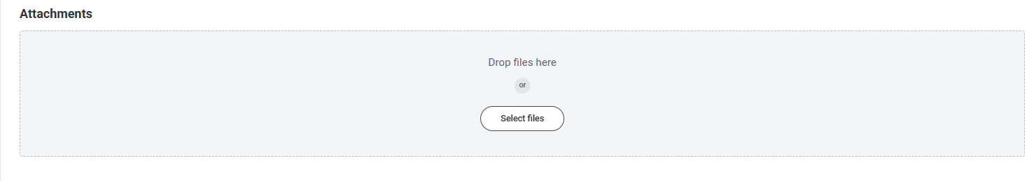

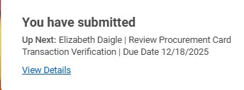
- Once all information has been entered and the supporting documents have been attached, click submit. A box will appear saying you have submitted and will list the next person who must approve the transaction.

- Select View Details to find the Workday Transaction Number (PC-00#) and note this number for future reference. This number will be helpful in finding the transaction later and determining the status of the verification in Workday.

Next Steps
After verifications are submitted, transactions go through a 100% audit approval process, with each transaction being reviewed by the cardholder's supervisor and the business office. Reviewers are confirming that all accounting details and documents are complete, accurate, and appropriate. Verifications requiring corrections will be sent back, with a comment included in the process history tab to describe the needed corrections. Verifications that are sent back will be designated as "Draft" status, pending correction, and re-submission. Upon completion of approval, the transactions being verified will be posted to the designated accounting funding source.

