Monthly Copier Usage Report
Version Date | October 2026
Policies & Resources | None
Forms | Monthly Copier Usage Report
Contacts | Purchasing@uada.edu
Related Guides | None

Introduction
If you have a leased copier, you will need to complete and submit a copier usage report to the UADA Purchasing Department each month. This report should be completed
- On the last workday of the month at the end of the day
- Early on the first workday of the following month
- When the numbers are requested by the copy machine vendor
Note: Copy numbers provided to the Purchasing Department via the Monthly Copier Report must be the same as those sent to the vendor. Such numbers should be reported within five days after providing them to the vendor.

Creating the Monthly Report
- From your copier, pull the COUNTER details for the month. If you are unsure how to find this information, contact the copier lease company.
- From the copier report, look for the printer and fax TOTAL copies that your office has made for the month. Circle or highlight the TOTAL number.
- Locate your office’s Monthly Copier Report from the previous month. You will need these totals to complete the current monthly copier report.
- From your computer, go to the UADA EMPLOYEES MONTHLY COPIER USAGE REPORT to obtain the form that you need to complete. You may want to save this link to easily access the report each month.
- The blank report will look like this:
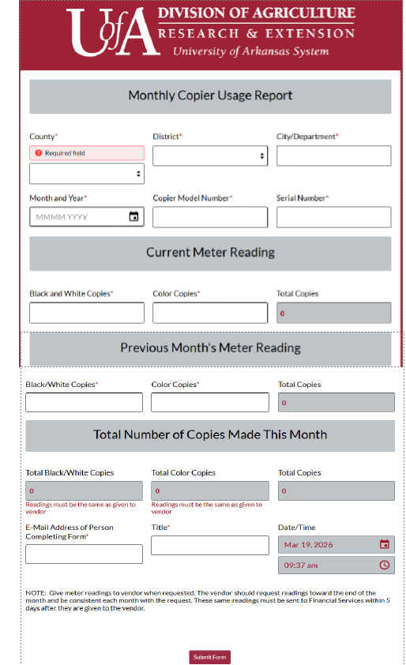
- Complete the form by selecting your county.
- Tab once to select your District from the drop down.
- Tab and type in your city.
- Tab and type in the date.
- Tab and enter the copier model number and then serial number from the Status Page/Counter Report, the prior month report, or form provided by the lease company.
- Using THIS MONTH’S Status Page report, look under Current Meter Reading and fill in the total number of Black and White Copies, Color Copies, and Total Copies.
- Using LAST MONTH’S Status Page report, look under Current Meter Reading and fill in the number of Black and White Copies, Color Copies, and Total Copies reported.
- Tab through the TOTAL BLACK/WHITE COPIES, TOTAL COLOR COPIES AND TOTAL COPIES. These blocks will automatically calculate the number of copies made.
- Tab and complete your email address and title.
- Click Submit Form. This will send the report directly to the Purchasing Department.

Next Steps
Once submitted, the report information will be auto emailed to the preparer of the report. This email may, but is not required, to be saved electronically or in hard copy for future reference, if needed. If the county exceeds its allotted number of copies for any given month, there will be extra charges. These charges show up in Workday as an ISD that must be approved. These charges will be settled through M&O and will affect the budget. If copy overruns are frequent, usage levels may be reviewed and adjusted for the next lease renewal term.

