Monthly Club Reporting
Version Date | October 2026
Policies & Resources | None
Forms | No Official Forms
Contacts | Finance@uada.edu; Assistant Vice President for Finance & Administration; Cash@uada.edu
Related Guides | Start-Up Instructions & Templates (for this Guide)

Introduction
The recommended method of generating and reporting financial information for club treasurers requires (1) tracking transactions as they occur in a Transaction Log, (2) generating a Workday report monthly, and (3) reconciling the two.
Account balances in Workday will rarely reflect available balances, because Workday only includes transactions that have been fully approved and posted. However, in most cases, there are many additional transactions that are in process or not yet entered in Workday. Therefore, adjustments must be made to the ending monthly balance shown in Workday to determine the available balance in a particular club’s designated work tag account. The remainder of this guide describes the creation and use of a Transaction Log, how outstanding transactions can be identified, Workday reports reconciled and agreed-upon information communicated to club treasurers in a timely and consistent fashion.

Creating the Transaction Log
Because club treasurers and County Administrative Personnel need available balance information throughout the month, it is recommended that county administrative personnel maintain a spreadsheet, similar to a check register, throughout the month. We will call this spreadsheet a Transaction Log. The Transaction Log below shows data for September and October, because those are the months we will need for an example we will use later in this guide. However, the Transaction Log would have started July 1.
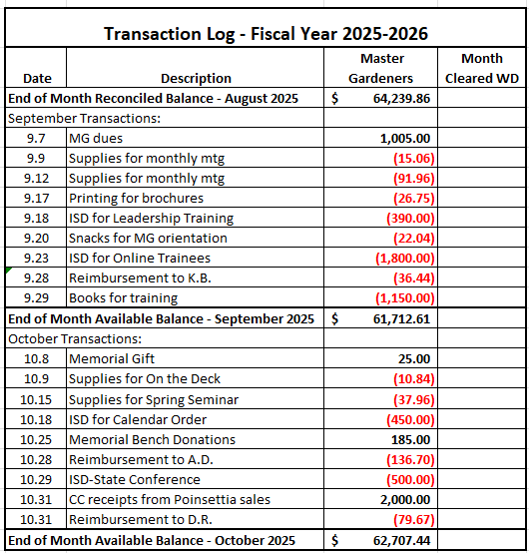
Note: Dates, descriptions, and/or amounts used in examples are fictitious and presented for illustration purposes only.
- To create the transaction log, as you become aware of transactions affecting club accounts, enter the underlying date of the transaction (or something close-it does not have to be exact), a brief description of the transaction (enough to locate the related paperwork), and the amount of the transaction. Recorded transactions might be P-Card purchases by an agent, ISD (Internal Service Department) charges from the state program office, purchases by volunteers are expected to be reimbursed, purchases with county checks, etc.
In addition to entering transactions in the Transaction Log, it is recommended that a file (hard copy or electronic) of the support for the transaction be maintained until the item posts in Workday and has been reconciled in the monthly process.
Note that the Transaction Log date is meant to be the date of underlying transaction which occurred which may be significantly earlier than the Accounting Date in Workday. This is because the Accounting Date on Workday is not the date the underlying purchase or receipt of funds occurred but is instead the date the transaction received all approvals and posted to the account on Workday.
A significant benefit of maintaining a Transaction Log is that it will show the true available balance at any point during the month. In the illustration below, the last two transactions dated 10.31 were removed to show that the balance adjusted, as appropriate. As long as the SUM formula is in place in the cell for the End of Month Available Balance ($60,787.11 below), that number will reflect all transactions entered to date and be the current available balance throughout the month.
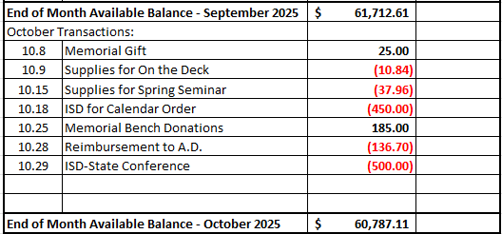
The next task is the generation of the monthly Workday report of account transactions and balances followed by formatting and reconciling the report. The report described below should be generated after the 15th of the following month so the reporting month will be closed and more transactions posted.

Generating the Workday Report
- In the Workday Search Bar, type RPT – Balance by Designated and click OK.
- Click on the Report name RPT – Balance by Designated that comes up in the search.
- In the parameters, fill in the Company name, the designated hierarchy, your county’s cost center number, and the Time Period and Period fields as shown in the illustration below.
- Once you fill in all the parameters the first time, before you click OK, type a name in the Filter Name field (Maybe something like Club Reporting), and then click Save.
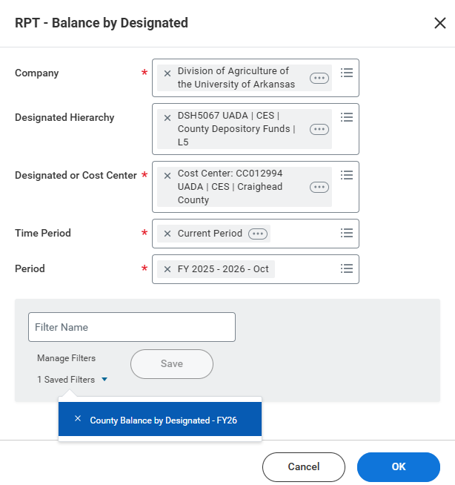

- Click OK and the report will generate. See illustration below. The next time you access this report, you can go down to manage filters and click on the drop-down arrow next to saved filters and choose the report you saved.

RPT - Balance by Designated

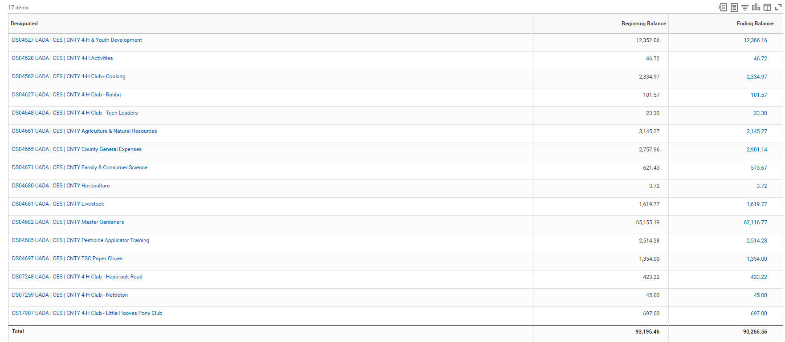

In the Designated Column, you will see a list of all Designated work tags related to your county bank account. Notice that all have “CNTY” in the description which indicates these are transactions from your county bank account. Not all of these Designated Workbags will be related to Club Accounts. Most that are related to Club Accounts have “Club” in the description.
In the report parameters, we used Current Period for the “Time Period” parameter and FY2025-26-Oct for the “Period” parameter. When using these periods, the Beginning Balance numbers in the middle column of the report represent the balances at the beginning of the designated month (October in this case) and the Ending Balances represent the balances through the end of that month. The Ending Balance will include all Workday transactions that have been completed. Any transactions still in process will not be included.
If you use Current Period YTD for the Time Period parameter instead of Current Period, the beginning balance will be the beginning of the fiscal year. The ending balance will be for the month designated in the Period parameter, so FY2025-26-Oct will result in the ending balance for October, if the month is closed. If the month selected is still open, you will simply get the current balance for the open month as of the date you run the report which will likely change when that month closes.
The Ending Balance Column numbers are blue font which indicates you can drill down for further detail. If you click on the actual number, Workday will bring up another screen with more details of that number.

Exporting the Report
- If you click on the arrow to the right of the number (you have to hover over that area to see it), there will be options for Exporting just the detail for that number. Those options are the bottom 2 selections in blue. To further format the information, please choose Export to Excel (All Columns) as shown below.

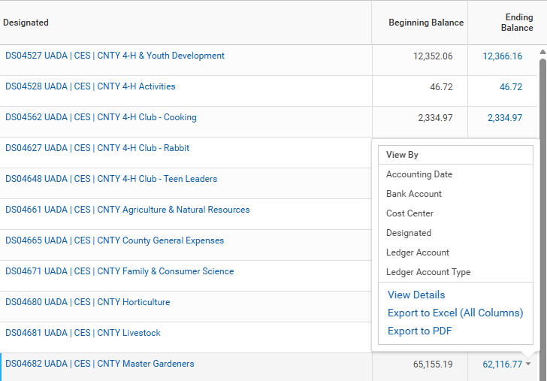

The exported report (below) will have lots of columns you will not need as well as some duplicate columns, so it is helpful to reorganize/format the report.

Exported Report of Account Detail:
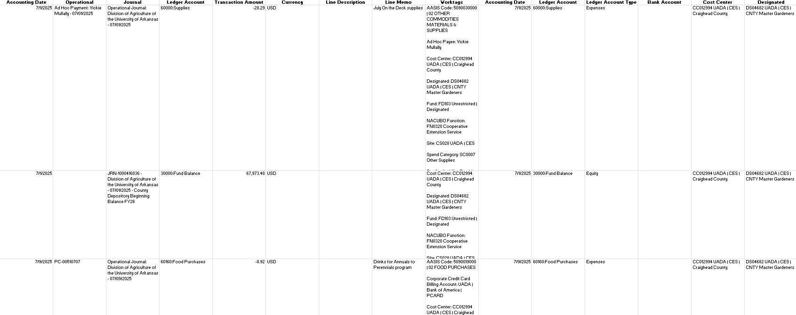

Formatting the Report
- To make the report more user-friendly, first delete all columns except:
- Accounting Date
- Operational Transaction
- Journal
- Ledger Account
- Transaction Amount
- Line Memo
As shown below, deleting the unused columns will significantly reduce the width of the report which also shortens the length.
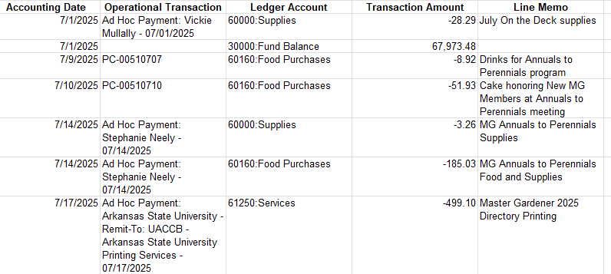
- Next, delete the Fund Balance row and all transactions with an Accounting Date prior to the reporting month. (Note: If the Period was designated properly, in this example FY2025-2026 – Oct, there should not be any transactions after the reporting month.)
- Insert a row below the header row and in the Ledger Account Column, type "Beginning Balance". In the Transaction Amount Column enter the beginning balance for that month for that particular designated work tag. This number can be found in the Beginning Balance column of the original report before you exported the detail.

- At the bottom of the transaction detail, in the next blank row, type “Ending Balance” in the Ledger Account Column and then enter the Workday Report Ending Balance for that designated tag in the Transaction Amount Column. This number can be found in the Ending Balance column of the original report before you exported the detail.

- In the column to the right of the Line Memo column and the same row as the ending balance, use the SUM function to double-check that the Beginning Balance plus any current month revenue and less any current month expenses equals the Ending Balance you previously entered in the last row. If you do not get the number shown as Ending Balance per Workday on the report, something has gone wrong!
- Every report should have a heading that includes a descriptive title and time period covered. In addition to the heading shown below, you might want to include a “Prepared by” line and possibly “Date prepared.” All this information can be helpful to you later and even more helpful for others using the report in the future.
Your formatted report should look something like this:
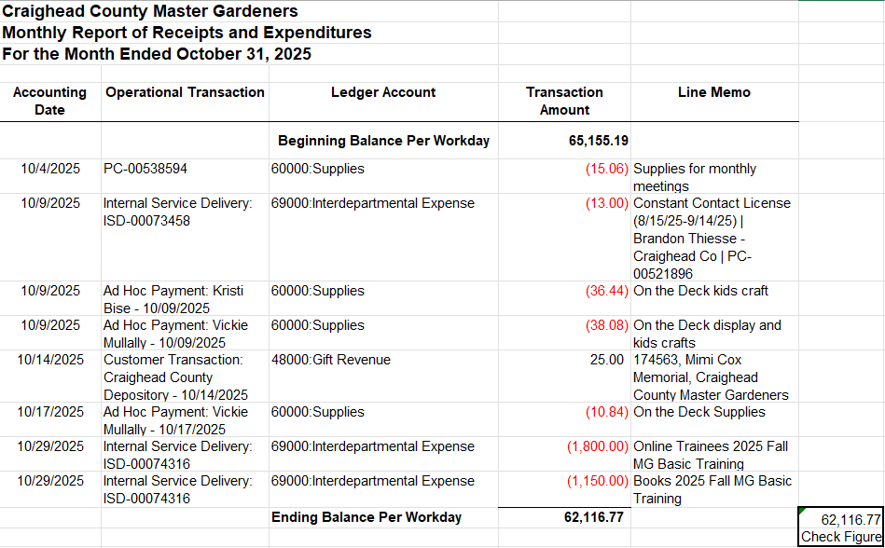

Reconciling the Workday Report and Transaction Log
As discussed earlier, the ending balance (per Workday) will rarely reflect the actual available balance, which is what county personnel and volunteers need. Therefore, adjustments will need to be made to the ending balance shown in this report to determine the available balance in a particular club’s designated work tag account.
To know what adjustments to the Workday report are needed, County Administrative Personnel need to determine which items in the Transaction Log are included in the Workday balance and which are outstanding. Outstanding items represent timing differences between the Workday report and the Transaction Log. These outstanding items that are included in the Transaction Log but not the Workday report should be added to or subtracted from the Ending Balance per Workday to determine the end of the month Available Balance.
The next step in the monthly reporting process is to identify the underlying transaction month for all transactions that cleared in Workday during the reporting month--in this case, October, and simultaneously record the Month Cleared WD in the Transaction Log.
- Add a column to right of the formatted Workday report and title it “Month per Transaction Log.”
- For each transaction in the Workday report, locate the transaction in the Transaction Log and note the month from the Transaction Log in the new column of the Workday report.
Notice in the illustration below that most of the transactions included in the Workday report for the month of October originally occurred in a prior month. This will often be the case, so you will need to review several months’ transactions in the Transaction Log to locate all the transactions in the Workday report. Also note that you will be looking for entries in the Transaction Log that do not have anything entered in the Month Cleared column. This will make your search easier.
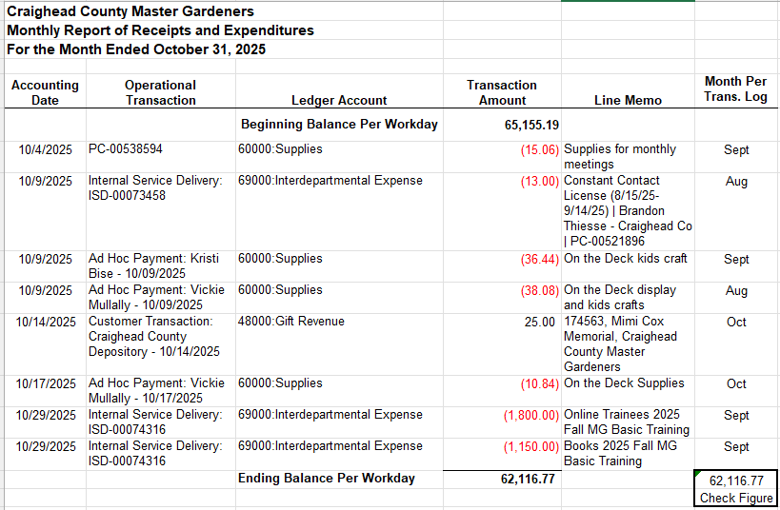
- As you locate transactions from the Workday report in the Transaction Log, record “Oct” in the Month Cleared WD column of the Transaction Log as shown below.
Note: The illustration below only shows September and October. As shown above, two of the transactions that posted to Workday in October originated in August. We would have also recorded “Oct” next to those August transactions.

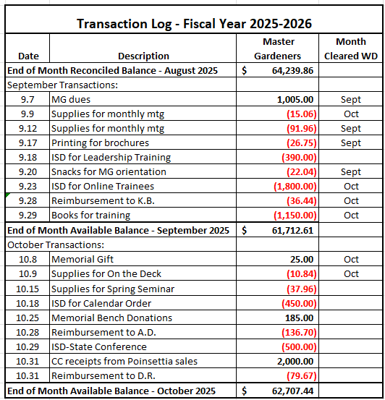
At this point, identifying outstanding transactions – those that have been recorded in the Transaction Log but not in Workday - is easy. Any transaction in the Transaction Log that does not have a month entered in the Month Cleared column is outstanding. Remember, there can be a significant time lag in a transaction posting in Workday, so you may have to look back several months and even to prior years to locate all outstanding transactions.
With outstanding transactions identified, the formatted Workday report can be reconciled to the Available Balance per the Transaction Report.
- At the bottom of the Workday report, immediately following the Ending Balance Per Workday, add Outstanding Deposits as shown in the Transaction Log and subtract Outstanding Payments to arrive at the Available Balance at the end of the reporting month.
- Compare the Available Balance from the adjusted Workday report to the end of month balance on the Transaction Log. These two numbers should match.
If the number calculated for Available Balance on the Workday report does not equal the End of Month Available Balance per the Transaction Log, something went wrong.
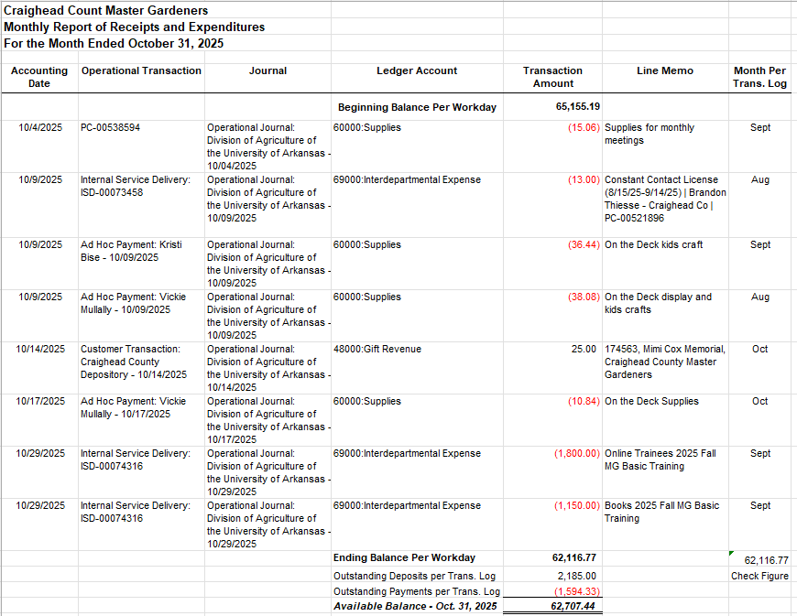

What Can Go Wrong?
There are two places in this guide where we said numbers should match. The first was when you format the Workday report and calculating the Check Figure. We assumed the calculated Check Figure was the same as the Ending Balance reported on Workday. What if it isn’t?
The primary causes of obtaining different balances are either:
(1) Some transactions from previous months were included when they shouldn’t have been or
(2) Not all October transactions were included in the formatted report.
Both problems are caused by deleting the wrong transactions from the Workday report during the formatting process. To correct these problems, return to the original exported report and start by reformatting the report, paying close attention to which rows are deleted. Only rows prior to the start of the reporting month should be deleted.
The second time this guide discusses the need for numbers to match is when you are reconciling the Workday report to the Transaction Log. Available Balances not matching between these two reports is far more likely than the Check Figure not matching the Ending Balance per Workday described above. There are several things that can cause errors between the Workday report and the Transaction Log including:
- Transactions omitted from the Transaction Log
- Transactions entered twice in the Transaction Log
- Transactions entered at a different amount in the Transaction Log than what was recorded in Workday
- The Excel spreadsheet used for the Transaction Log is not functioning properly – Probably because the Sum function is not picking up all the proper cells
- Failed to record that a transaction cleared in the Transaction Log, so it is treated as outstanding when it is not
- Miss adding (or subtracting) outstanding transactions when determining the adjustments necessary at the bottom of the Workday report
To address the most likely problem first, recalculate outstanding items, making sure all are accounted for and determine whether they should be added or subtracted in the Workday report. If your numbers still do not match, find the difference between the balances from the two reports. If the Workday balance is smaller than the balance from the Transaction Log, you have subtracted too much on the Workday report. This could be the result of not recording that an item had cleared on the Transaction Log and treating it as outstanding. If the Workday balance is more than the Transaction Log balance, a deposit may be treated as outstanding when it is not. Also, a transaction could be entered into (and therefore subtracted from) the Transaction Log twice.
It would be easy to accidentally omit an entry from the Transaction Log, and you may not realize that happened until you see the transaction on the Workday report and do not have a corresponding entry in the Transaction Log. That is easy to fix. Add a row to your Log and enter the transaction in the location it should have originally been entered. Double check the Sum function for the month to make sure it is picking up the newly entered transaction.
As you work through the identification of differences between the Workday report and the Transaction Log, you may need more information about a particular transaction. The next section describes some ways to find that information.

Drilling Down
Sometimes there are questions about the specifics of a transaction and more detail is needed. This may occur for instance if the balances you are trying to reconcile do not match after accounting for outstanding transactions and you are trying to verify the amount of a specific transaction that has cleared Workday.
The image below is an excerpt from the RPT-Balance by Designated report shown earlier in this guide. Notice the ending balance of 62,116.77 is in blue font. That means you can drill down and see the details of what makes up that number. From there, even more detail can be obtained.
- Click on the ending balance and a large box will appear in the top left of your screen. Notice in the bottom right corner, you can navigate to different pages (if there are multiple pages). Also notice two diagonal lines in the very bottom right corner. If you hover your mouse over those lines, a line with arrows on both ends will appear. At that point, you can left click, hold, and drag the box to make it larger.
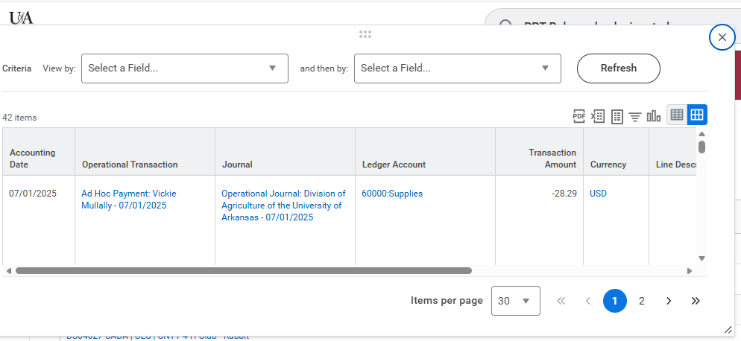
- Search through the list of transactions until you see the one you want to research. Suppose for example, you need more information about reimbursement to a volunteer. Personal reimbursements present as an “Ad Hoc Payment” followed by the payment recipient’s name and accounting date in the Operational Transaction (second) column of the transaction detail table as shown below.

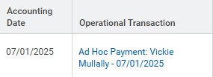
When you find the reimbursement you want, click on Ad Hoc Payment in the Operational Transaction column and the following screen will appear.
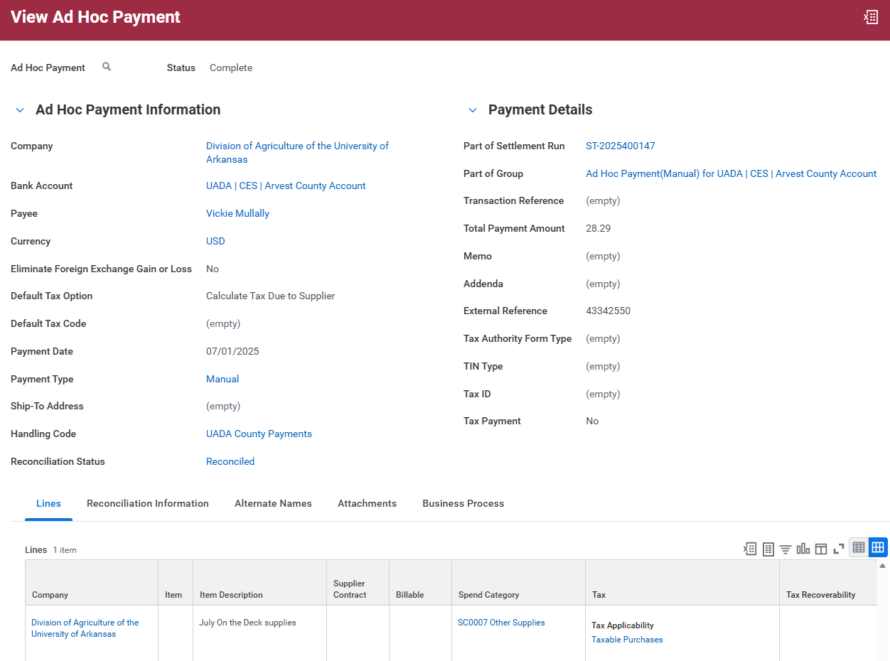
- On the screen above, any text in blue can be selected to see more detail. In addition, the line above the table – slightly below the middle of the image -- has terms that have more information underneath, even though the text is not blue. For example, selecting Attachments allows you to see supporting documentation such as the receipt, Payment/Purchase Request form, etc. (Note: When viewing attachments, be sure to look in the top center of the screen to navigate multiple pages. You can’t just scroll down to find them.)
Another useful tool on this screen is the “Business Process” tab, just to the right of Attachments. Selecting this tab allows you to see what approvals the transaction has received, which may help determine where/if it is held up in the process.
- As another example, if you need to research a P-Card transaction, you will find the P-Card transaction number in the Operational Transaction column and select the blue text.
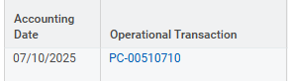

The detail screen for P-Card transactions (shown below) is slightly different from that of an Ad Hoc payment, but the same search principles apply, i.e. blue text has drill-down information as does the line of terms containing “Information, Process History, Attachments, and Transaction Details.” However, with P-Card transactions, often the attachments are found at the bottom of the Transaction Details page, and not under the Attachments tab.
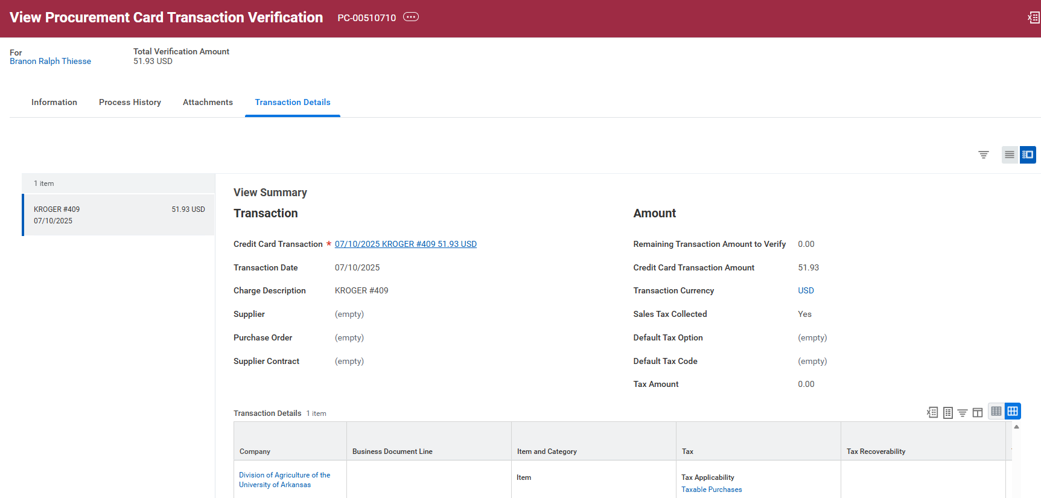

Sharing the Information
Exactly what information is shared with club treasurers and when that information is shared will vary across counties and between clubs in the same county. Not all treasurers want or need the same information. For active clubs with highly involved volunteers, it may be best to provide the reconciled Workday report AND the transaction log through the end of the reporting month. This conveys full information and may even help the treasurer understand the frequency and magnitude of time lags between when transactions occur and when they clear and post in Workday. In other situations, this much information may overwhelm or even confuse the treasurer. In those situations, sharing just the Transaction Log or just the reconciled Balance by Designated report may be preferable.
Courteous and appropriate communication between county personnel and volunteers is vital to the administration of our programs. The more accurate and timely information club treasurers receive the better they can help manage club financial activities. However, information sharing should not be overly burdensome to county administrative personnel. Therefore, it is important that communication expectations be established and managed to the benefit of all parties.

