In-State and Out-of-State Travel
Version Date | October 2026
Policies & Resources | Travel UADA Policy 380.1
Forms | Travel Authorization Form  Travel Method Comparison Worksheet  TRAV-207 (Mileage)  Affidavit of Lost Receipt
Contacts | Travel@uada.edu; Acountspayable@uada.edu
Related Guides | Using Travel Cards; Travel Card Expense Reassignment; Completing a Workday Expense Report, Completing a TRAV-207

Introduction
This guide discusses in-state travel and the process of acquiring approval and reimbursement for domestic out-of-state travel. This guide does not address international travel. Travel is governed largely by State of Arkansas regulations as administered by the Arkansas Department of Finance and Administration, although the University of Arkansas Division of Agriculture has some additional procedures.

In-State Travel
In-state travel includes travel within the 75 counties of Arkansas. Exceptions exist for employees in counties on the border with another state if the travel is programmatic and does not include overnight lodging. In-state travel does not require prior approval.
In-state travel expenses can include mileage only, or it can include expenses associated with an overnight stay. Such expenses may include registration, lodging, meals, and parking expenses in some cases. Receipts are required for all expenses although meal receipts are not submitted with the related expense report.
Expense reports for in-state travel should be completed monthly and must be submitted by the 5th business day of every month. (If not submitted within 20 business days, special approval is required before the expense report is submitted.)

Process

If County Administrative Personnel complete travel for agents, those agents with in-state travel should submit all documentation to the County Admin at the conclusion of the month. Based on documentation received, the Admin will complete a TRAV-207. (See Completing a TRAV-207 process guide.) Once complete, the TRAV-207 should be saved as a pdf.
As previously stated, in-state travel can involve multiple types of expenses. However, mileage is by far the most common. Although more fully discussed in Completing a Workday Expense Report, the section below explains how to enter in-state mileage in a Workday Expense Report.

Completing the Expense Report
First, it is helpful for the Business Office if the header contains a brief description of why the Expense Report is being created. On the initial screen of Create Expense Report for Worker task, use the Memo line to describe the purpose of the Expense Report.
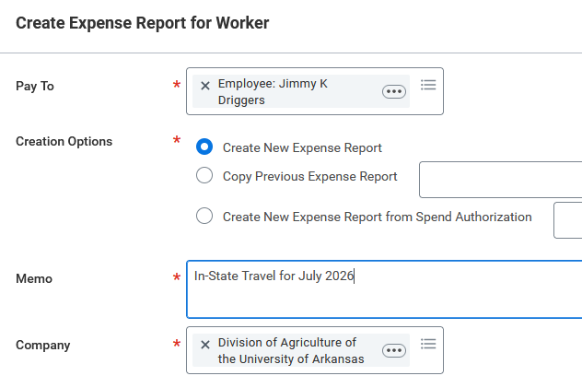
That description will then auto populate in the Memo line of the next screen and will be visible in the Header. To verify or modify the description, select the Header tab and then review the verbiage in the Memo line. As shown below, if the report is being created to reimburse monthly mileage, type In-State Travel for July 2026 or something similar. The description in the Memo line will appear in the red header box, up to a character limitation.
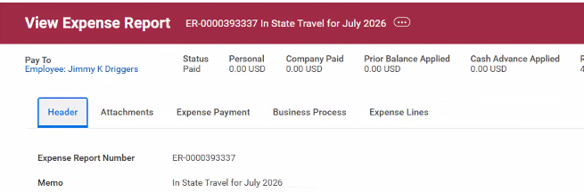

After completing the initial screen titled Create an Expense Report for Worker and selecting the blue OK button, an Expense Lines tab will open. Select the Blue Add button and the screen below should appear.
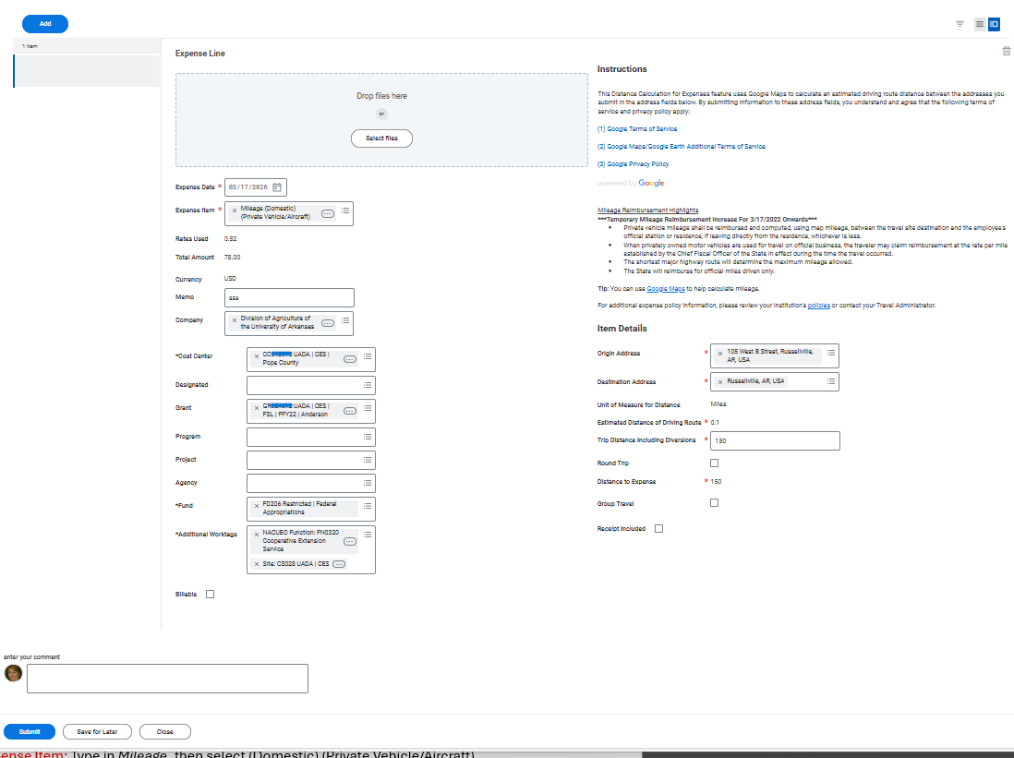

Complete the fields as follows:

Field Name | Response
Drop Files here | Attach Trav-207 (Note: Earlier guidance was that all receipts be scanned together and uploaded here. However, current best practice is to upload only the relevant receipt to each expense line.)
Expense Date | Select the last day of the month Ex. January 31, 2026
Expense Item | Type in Mileage, then select (Domestic) (Private Vehicle/Aircraft)
Total Amount | Leave blank
Currency | Will auto-populate USD
Memo | Type in See attached TRAV-207 (if multiple funds are being used, include worktag on each line)
Company | Will auto populate to Division of Agriculture of the University of Arkansas
Cost Center | This will auto populate the traveler’s name/headquarters. (Change if needed to charge to different Cost Center.)
Designated (DS worktag)  Grant (GR worktag)  Program (PG worktag)  Project (PR worktag)  Agency (AG worktag) | Leave blank unless you are using funds from a specific source.
The remaining fields in the left column will auto-populate. Tab to Item Details
on right column.

Origin Address | Enter the complete address of your headquarters
Destination Address | Type in your headquarter Town and State (only)
Trip Distance Including Diversions | Enter the total miles driven for the month per the TRAV-207, separating out mileage for different funds, if multiple funds are being used.

To split mileage between two or more worktags, you will need to enter additional lines by clicking the blue Add button and completing all fields again. Once all mileage lines are entered and TRAV-207 uploaded, select Submit to begin the approval process.

NOTE: ANY trip that has expenses other than just mileage MUST be reported on a separate Expense Report with a separate TRAV-207.

Out-of-State Travel

Obtaining Travel Approval
All out-of-state travel requires prior approval. To obtain approval, a Travel Authorization Form must be completed. If the proposed mileage is over 800 miles round trip (400 each way) and the traveler chooses to drive, a Travel Method Comparison Worksheet must also be completed. Both forms should be submitted (and approved) as soon as the information is available but no later than 2 weeks prior to the start of travel. No travel expenses (including airfare) should be incurred prior to approval. Early approval is best practice.

Travel Method Comparison Worksheet & Travel Authorization Form
If the proposed trip is over 800 miles, roundtrip, a comparison of each method (drive or fly) must be documented on the Travel Method Comparison Worksheet. Unless otherwise authorized, the traveler is entitled to reimbursement for the lower cost option. Mileage included in the comparison should be verified via Google Maps, and documentation should be submitted with the Travel Method Comparison Worksheet. A screenshot of the estimated cost of airfare is also required.
If the traveler is driving, the total estimated mileage should be shown in the Miles column with a note in the Personal Vehicle justification field that only the Airfare in Lieu of Mileage estimate will be claimed.
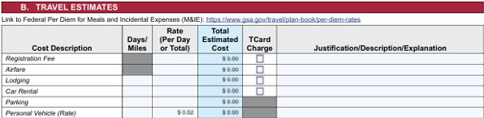
It is critical that absolutely every expense be included on the Travel Authorization Form—at the maximum amount anticipated/allowed. For example, it is best to list the maximum daily limit for meals. Failure to include an expense on the Travel Authorization Form may result in that expense not being reimbursed. Expense items not included in the original spend authorization may not be eligible for reimbursement. Such items require a detailed justification in the memo line field.
All documents are submitted to the Staff Chair (if not the traveler) and then District Director or just District Director if the Staff Chair is the traveler. When travel is complete, all these documents are attached to the Expense Report in Workday. In addition, if the traveler chooses (and is approved for) driving instead of flying relative to out-of-state travel, a TRAV-207 must be completed after travel is concluded and attached to the Workday Expense Report.
Complete all fields.
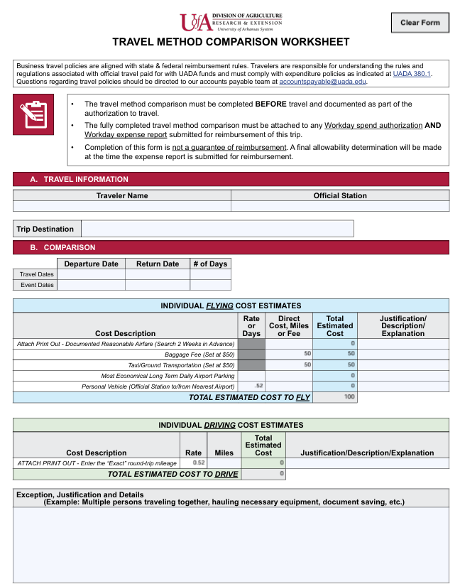
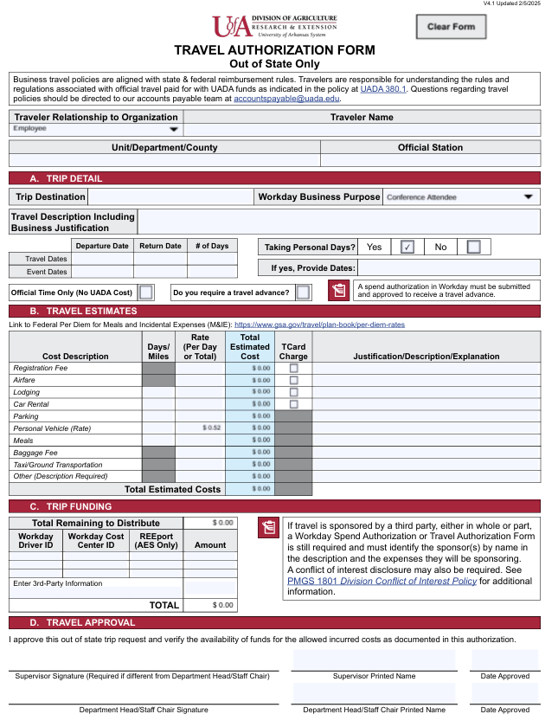
Complete all fields.

Allowable Expenses & Required Documentation

Below is a list of allowable expenses and another of required documentation. Note that if airfare is approved for the planned travel, it may be purchased using a Travel Card (T-Card) or personal funds. Travelers are eligible for reimbursement for airfare only AFTER the trip has ended and the Workday Expense Report is fully approved and processed by the Business Office.

Allowed (Reimbursable)
• Airfare (i.e., coach class, main cabin, economy, for domestic flights)
• Car rentals using the State Contract (with appropriate justification). Please note that if requesting a car rental, the Spend Authorization through Workday is required in lieu of the Travel Authorization form. Renters should not add insurance when renting vehicles since rental coverage is included in the UADA business insurance policy. Additionally, fuel purchase options or prepaid fuel are not allowed with vehicle rentals.
• Fuel for rental vehicles (purchased at gas pump)
• Lodging, including associated taxes and fees
• Meals with an overnight stay (Actual costs must be reported up to per diem amounts; claiming per diem all the way across is not allowed.)
• Mileage, at rate authorized by Chief Fiscal Officer of the State
• Parking fees
• Registration fees for conferences/training
• Taxis, shuttle, ride-share, or related services, excluding tips
• Tips associated with meals while in travel status (up to 15%) not to exceed maximum per diem limit

Receipts Required
• Airfare (must include complete itinerary, passenger name, dates of travel, date and proof of purchase, seat class, and any service fees; reservation confirmation notice NOT acceptable)
• Bag fees
• Car rental (reservation confirmation notice NOT acceptable)
• Communication expenses (phone, internet, etc.)
• Group meals or “Official Function Policy” meals
• Items purchased while in travel status (must include detailed explanation of why items were needed)
• Lodging (must be itemized; credit card receipts without itemization or reservation confirmation notice NOT acceptable); Receipt must show a zero balance.
• Parking
• Registration fees
• Taxi/ride-share (tips NOT reimbursable)
• Toll fees
• Train

Next Steps
All documents involved in the approval of travel should be held in the county office until travel is complete. As soon as planned travel is completed, the related Expense Report should be submitted in Workday. (See the Completing a Workday Expense Report process guide.) Once the Expense Report is approved, any charges paid by the traveler with personal funds will be reimbursed. Reimbursement is usually made via direct deposit to the account designated by the traveler for expense reimbursements.

