Creating and Using ISDs (Internal Service Delivery)
Version Date | October 2026
Policies & Resources | None
Forms | None
Contacts | Cash@uada.edu
Related Guides | Private (Pesticide) Applicator Training

Introduction
Internal Service Delivery (ISD) transactions are used to record internal transfers of funds from one department or account to another. For example, an ISD would be used to record registration by a UADA employee at a UADA event/educational seminar. ISDs are not appropriate for paying a third-party vendor. Common uses of ISDs include:
- Paying for UADA publications
- Paying certain state association dues such as AAE4-HA, NEAFCS or ACAAA.
- Counties paying a UADA department for Poultry Chain chicks
- Paying the Print Shop for services
- Sending Pesticide Applicator Training money to the Entomology Department
- Paying the Family & Consumer Science department for ServSafe training material

Entering an ISD in Workday
In the Workday Search Box type: Create Internal Service Delivery and hit Enter. The following screen should appear. Complete the fields as described in the table below.

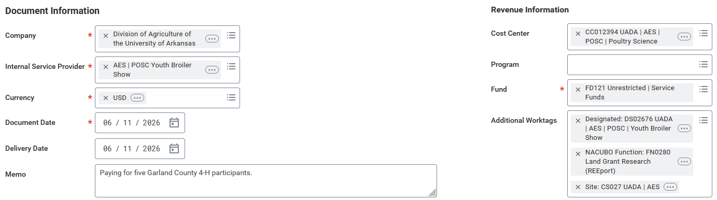

Internal Service Delivery – Document Information
Field Name | Response
Company | Auto populates to Div. of Ag
Internal Service Provider | Use the drop down list to select the department you are paying and, at a high level, why you are paying them. If you don’t see what you need, contact Cash Management at Cash@uada.edu for assistance.  Note: When the Internal Service Provider is selected, most of the Revenue Information on the right side of the screen will auto populate. Do not change this information. You may leave Program blank.
Document & Delivery Dates | Default to current date. Leave as is.
Memo | Enter a description of why you are making the payment. Note: You’ll need to copy this and paste it in another field later in the form.

In the bottom portion of the screen with Lines selected, click the + to add line and complete the fields as described in the table below.
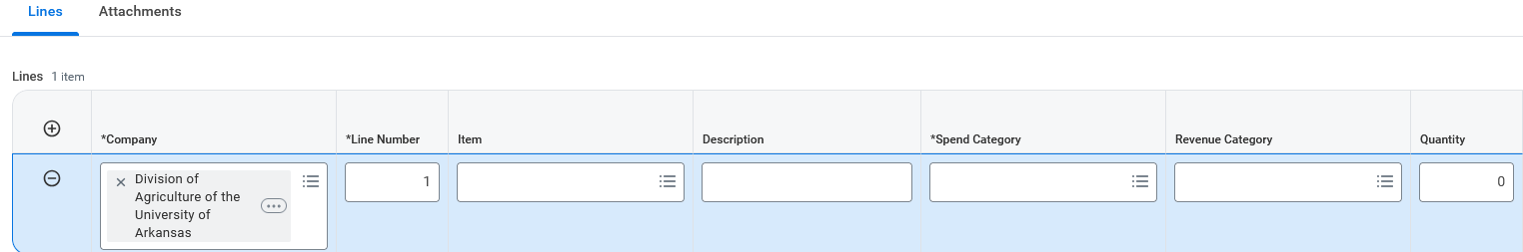
Put your cursor in the blue area toward the bottom of the screen to make the scroll bar appear and scroll to the right to reveal more fields.
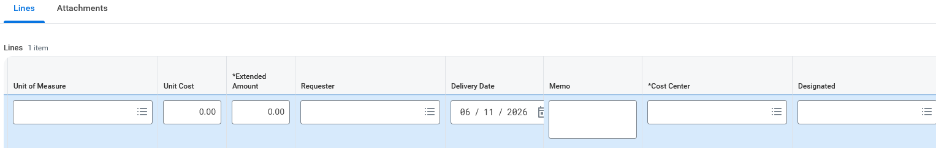

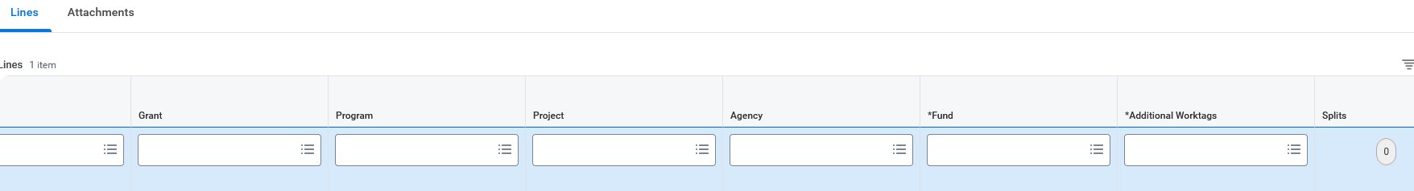

Internal Service Delivery – Completing “Line” Information
Field Name | Response
Company | Auto populates to Div. of Ag
Line Number | Auto populates
Item | Should be a drop down to choose from. The choices will vary depending on the Internal Service Provider entered.
Spend Category | Should auto populate after item is selected.
Revenue Category | Should auto populate.
Quantity | Must put something here. Usually, 1 will work unless you are paying for multiple items.
Unit of Measure | Should auto populate.
Unit Cost | Will auto populate once Extended Amount is entered.
Extended Amount | Enter total amount of payment to be made on this line item.
Requester | Type in your name.
Delivery Date | Auto populates to current date.
Memo | Paste what was copied from Memo line in Document Information above.
Cost Center | Enter cost center from which the payment is to be made.
Designated | Enter worktag associated with where the payment is to come from, if any.
Grant/Program/Project/Agency | Enter Grant/Program/Project from which the payment is to be made, if appropriate. Agency is rarely used.
Fund | Auto populates.
Additional Worktags | Use if payment is to be split between multiple worktags.
Splits | This is rarely used.

Select Attachments next to Lines. Scan documentation into one file and either drag the file to the attachment area or select the file from your computer.
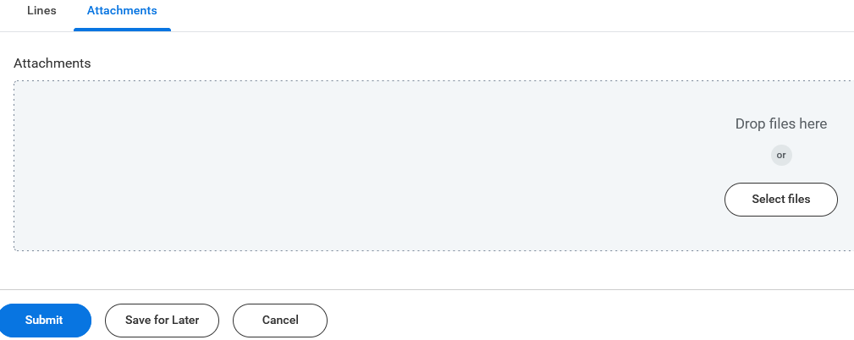
When you are finished, select the blue Submit button at the bottom of the screen.

Next Steps
After the transaction is submitted, you will receive a notification that the transaction was successfully submitted with a link to view more details. The details include an ISD number that should be retained for future reference. Workday will route the transaction for approvals which typically include the Administrative Specialist of the recipient Cost Center used in the transaction, the Fiscal Support Analyst – County Operations, and the Cash and Treasury Manager. Depending of fund types involved (such as grants) other approvals may be required. The Fiscal Support Analyst and Cash and Treasury Manager review the transaction to make sure funds are available and that the type of funds used is appropriate for the payment purpose. When Business Office reviews are completed, the ISD will be processed through an overnight Workday procedures, and the funds involved will be posted to the designated accounts.

