Completing a TRAV-207 (Mileage)
Version Date | October 2026
Policies & Resources | UADA 380.1 – Travel Policy
Forms | TRAV-207
Contacts | Travel@uada.edu  AccountsPayable@uada.edu
Related Guides | In-State and Out-of-State Travel; Completing a Workday Expense Report

Introduction
The TRAV-207 form is required to be completed and submitted with the related expense report anytime reimbursement is requested for in- or out-of-state mileage. The TRAV-207 only documents mileage, not any other travel-related expense.
In addition to using the links provided in this guide, you may access the TRAV-207 as follows:
- Go to the UADA employees page.
- Click on Finance icon under EMPLOYEE RESOURCES.
- Then select Travel. (Note: There are a lot of other travel resources on this page should you need them.)
- Select the Forms drop down menu.
- Click on TRAV-207 and the form you can download as an excel file to your designated location for editing.
- Open document and follow Instructions to the right of the Summary for Mileage Reimbursement header.
- It is recommended that you save a completed copy of your edits to your computer as changes may be required upon submission.
Completing the TRAV-207
- Collect the person’s mileage to be reported and download or open your saved TRAV-207 form.
- Make sure you are on the SUMMARY page of the excel workbook. The screen below should appear.
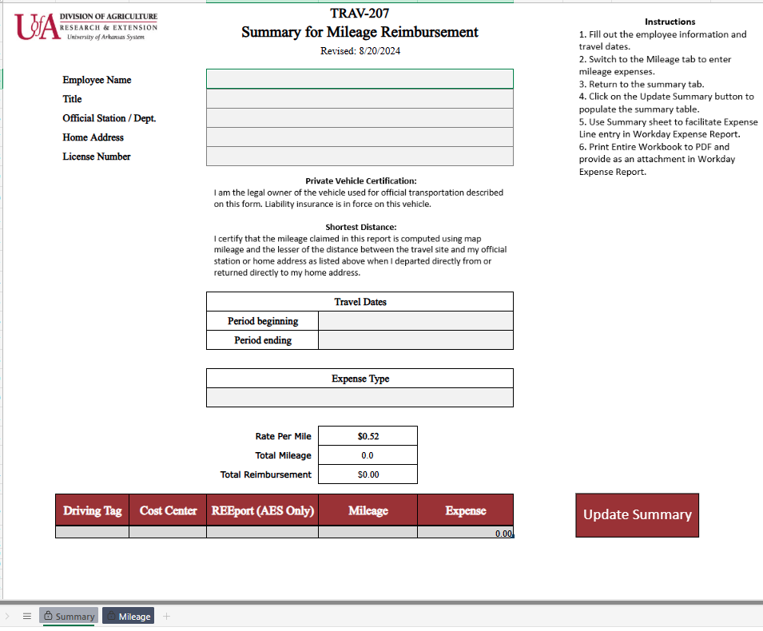

- Complete the Summary page as follows:
Trav-207 – Summary Page
Field Name | Response
Employee Name | Enter traveler’s name for whom the TRAV-207 form is being completed.
Title | Enter traveler’s title. Ex – FCS Agent
Official Station/Dept. | Enter the traveler’s home office location. Ex – Pope County Extension Office
Home Address | Enter the traveler’s home address.
License Number | Enter the license plate number of the primary vehicle driven.
Travel Dates | For in-state travel, enter the first and last day of the month for which the TRAV-207 is being completed. For out-of-state travel or travel to a specific event, enter the first and last actual day of travel.
Expense Type | Click in the gray box to show a dropdown arrow to the right. Select the arrow and choose OFFICIAL BUSINESS for monthly travel or EXTERNAL TRAINING if appropriate.
Total Mileage & Total Reimbursement | Will auto populate from the Mileage page.
Driving Tag, Cost Center, Mileage, Expense | Will auto populate when the Mileage page is complete.
Update Summary | After completing the Mileage page, return to the Summary page and click in the Update Summary box to update the information on the Summary page.

Once the Summary page is completed, select the MILEAGE tab of the excel workbook to continue. The information needed to complete the Mileage page should be submitted to you by the traveler. Complete all fields as described in the table below.

Trav-207 – Mileage Page
Field Name | Response
Date | Enter actual dates provided by the traveler.
Driving Tag, Cost Center | Enter the information for the funds to be used to pay the mileage.
REEport | Leave blank (For AES Only)
Purpose of Trip | Ex – Conduct embryology program to 2nd grade students. (This should be provided by the traveler.)
From Location, Departure Time | Complete with information provided by the traveler.
To Location, Arrival Time | Complete with information provided by the traveler.
Mileage | Enter mileage provided by the traveler and/or use Google Maps to determine distance traveled.


- When the Mileage page is complete, return to the Summary page and select the red Update Summary box.

- The last step is to save the file in a pdf format. To do this . . .

- Click File
- Click “Save as Adobe PDF”
- Choose “Entire Workbook”
- Click on “Convert to PDF”
- Save to desired file location

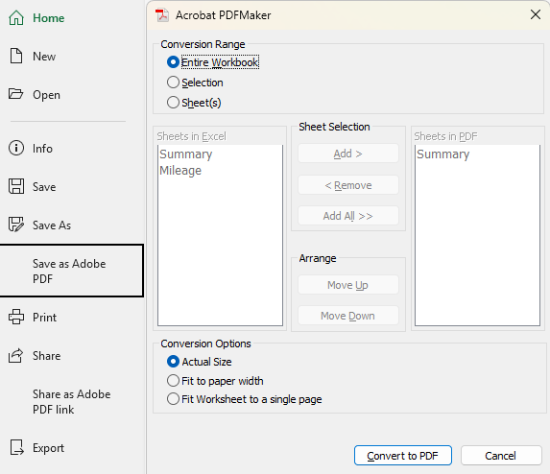

Next Steps
Once you have saved the completed TRAV-207, you are ready to create an expense report in Workday. Be sure to attach the TRAV-207 to the related expense line in the report. The Business Office will keep travel records for four business years plus the current year. Again, it is recommended that you keep the completed TRAV-207 forms, in excel format, until the related expense report is settled.

