Clover (Credit Card) Transactions
Version Date | October 2026
Policies & Resources | How to Operate the Clover Card Reader
Forms | Refund Request Form; Clover Device Credit Card Reservation Form; Gross Receipts for Sales Tax Form
Contacts | Cash@uada.edu
Related Guides | None

Introduction
County Extension programs such as 4-H and Master Gardeners often sponsor events where on-site registration and/or purchases occur. Increasingly, program participants prefer to use credit cards for those transactions. To enable the acceptance of credit cards to pay for registration and/or merchandise, the UADA Cash and Treasury Department supports the use of a credit card processing system called Clover. This guide addresses policies surrounding the acceptance of credit cards for program receipts, how to acquire, set up, and operate a Clover device, how sales tax is handled on Clover transactions, and how and when the financial settle-up between the Little Rock State Office and the county occurs.
The Clover system accepts payments from the following:
- American Express (OptBlue)
- Discover Card (Discover Network Full Processing)
- PayPal (Discover)
- Mastercard/Visa
- Debit (PIN and PINless)

Clover Transaction Policies

The first rule in accepting credit cards is that NO ONE is allowed to use any device or service other than that sanctioned by the Little Rock State Office. The sanctioned device and service is currently called Clover. While volunteers are allowed to operate Clover devices, neither employees nor volunteers are allowed to use any other products, including but not limited to Square, PayPal, and Shopify. In addition, separately incorporated groups such as Extension Homemakers are not allowed to use UADA Clover devices.
Other policies include the following:
- Never connect a Clover device to Wi-Fi – ever! (Clover has its own data plan.)
- Never take a credit card payment over the phone. The cardholder must be present for all transactions.
- Do not take payments for donations. Donations via credit card can be made at Donations to UADA.
- No refunds may be made through the Clover device. To request a refund, complete a Refund Request Form.
- Log off of the Clover device at the end of each day by turning off the device.

Obtaining a Clover Device
Most county offices have a Clover device. However, if you need one, or an extra one for an event, you should complete a Clover Device Credit Card Reservation Form. There is a $23 per month fee for each Clover device maintained in the county. This fee will appear in Workday as “Clover Credit Card Monthly Fee” and is charged regardless of whether the machine is used during the month.

How to Operate a Clover Device
Detailed instructions for how to operate a Clover credit card reader can be found in the document How to Operate the Clover Card Reader. In addition, when using a Clover device for taxable sales such as plants and related items at Master Gardener events, the operator of the Clover device should first select the appropriate county (Exhibit A) and then select “Plant Sale” (Exhibit B).
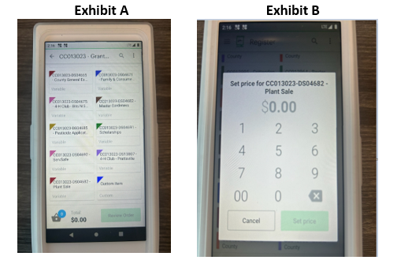
Note: Plant Sale should be selected for any taxable sale of merchandise, even if the item is something other than a plant.
When setting up a Clover device, it is critical that the correct Cost Center and Worktag be used. If set up incorrectly, some other county or department may receive the funds. Even if discovered, correcting the problem is extremely time consuming, because each entry for transaction revenue, fees, and sales tax must be individually reversed, and new entries entered in the correct account.

Supplies
Counties should purchase thermal paper rolls (2 ¼”) to generate receipts for Clover transactions. Below is an Amazon option.
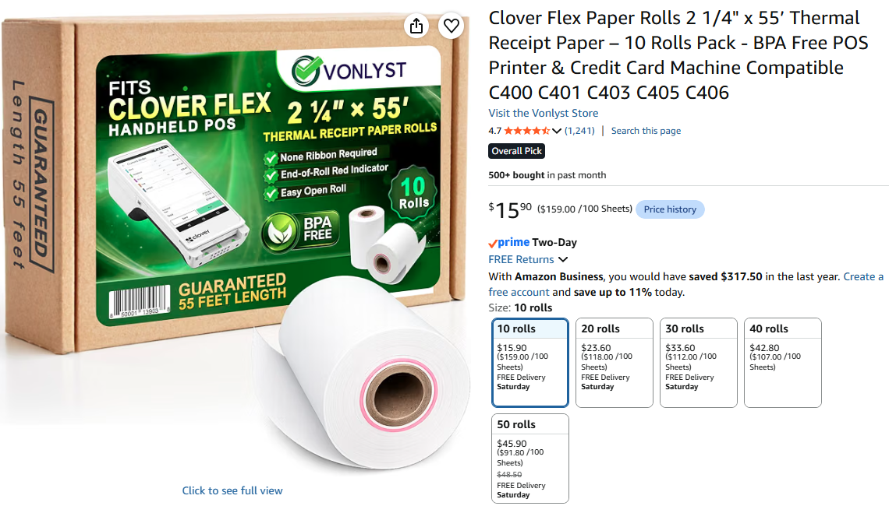

Credit Card Fees
Fees paid by the Business Office for Clover devices and processing services will be deducted from the cost center and worktag noted for each credit card sales transaction. Fees are calculated as follows:
- There is a minimum fee of $.1 per transaction.
- To the minimum, a fee of 2.6% of the gross receipt is added.
- In rare circumstances when card information is entered manually (rather than swiping the card), an additional 3.5% fee is charged.
Clover transactions are downloaded by the Cash and Treasury Department accountant in charge of this process three-to-four times per month. Each credit card receipt creates a row in the downloaded file that includes such information as:
- Date and Time of Sale
- Employee (Volunteer) ID
- Employee (Volunteer) Name
- Item and Order ID (from Clover system)
- Cost Center and Worktag
- Item Revenue
The accountant calculates the transaction fees and enters them in the spreadsheet. The spreadsheet is then uploaded into Workday, and the gross revenue and total card fees for each transaction are recorded in the designated Cost Center/Worktag.
In the example below taken from a Balance by Designated report, an individual credit card sale for $75.00 was recorded and reduced by fees of $2.05 ($.1 + ($75*.026)).

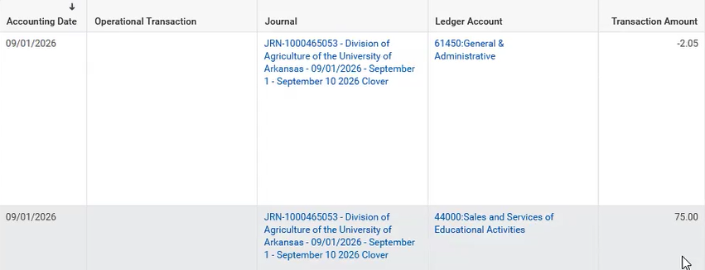
Note: Each transaction processed via a Clover credit card reader is recorded separately. Transactions are not aggregated by day or across a multi-day event.

Recouping Credit Card Fees
To cover the cost of credit card fees, counties may choose to add the fee to the price charged when cards are used with a Clover device. Counties may calculate the specific fee by dividing the cash price by 1 minus the fee percentage and adding $.10.
Continuing the example above, if the cash price is $75, the credit card price would be 75/(1-.026)+.1 = $77.10. To verify the price, we take 2.6% of $77.10 which is $2 and add $.10 to get a fee of $2.10. Subtracting this fee from $77.10 leaves the cash price of $75.
Alternatively, counties may choose to establish set fees for a range of prices. An example is shown below.

Minimum Cash Price | Maximum Cash Price | Credit Card Fee
$0 | $50 | $1
$50.01 | $100 | $2.5
$100.01 | $200 | $5
Etc.

Using a table like the one above simplifies the transactions and aids in consistency when multiple people, including volunteers, may be operating the machines.

Sales Tax
All receipts from taxable sales obtained through a Clover credit card reader are assumed to include sales tax. For example, if plants are sold to an individual for $20 and they pay with a credit card, the $20 is assumed to include the price of the plants AND sales tax. The gross receipts ($20) will be recorded in the appropriate account and then a journal entry will be made to remove the amount of sales tax that the state office calculates and remits to the Department of Finance and Administration (DFA). In this example, if state, city, and local sales tax totals 10%, the Business Office will make a journal entry to reduce the $20 by $1.82 (20 – (20 / 1.1)). The $1.82 will then be remitted to DFA.
As shown below, to facilitate sales tax processing by the Business Office, County Administrative Personnel are asked to note the existence of credit card sales on the Gross Receipts for Sales Tax form that is completed and submitted based on cash sales from the same event.
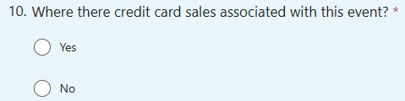

Checking this box helps notify the Sales Tax Specialist in the Little Rock State Office to look for credit card revenue related to that sales event. At the end of the month following the sale, the Sales Tax Specialist will run a report that identifies credit card revenue and uses that information to calculate sales tax on credit card sales. An entry is then made to reimburse the Business Office for tax from credit card sales remitted to DFA.

Next Steps
At the end of each day a Clover device is used, the designated operator should log out of the device. (The device will automatically log you out after a short period of inactivity, or you can turn off the device.) If extra devices were borrowed from the state office, these machines must be returned. Finally, it is important that County Administrative personnel make notes about the days Clover machines are used and for what event. If related revenue and fees do not show up in the designated accounts within about two weeks, contact Cash@uada.edu. If sales tax is not recorded within two months of the original sale, contact SalesTaxUADA@uada.edu.

